
MADDA WALABU UNIVERSITY
COLLEGE OF COMPUTING
DEPARTMENT OF COMPUTER SCIENCE
TITLE: SMART ATTENDANCE SYSTEM USING FACE RECOGNITION
Submitted to:-
College of Computing Department of Computer Science
Submitted by:-
1) BEKAM AYELE
2) BACHA ESHETU

SIGNATURE PAGE (Approval sheet)

Project Title:__________________________

Name of Students Signature Date
_________________ _______________ ______________
_________________ _______________ ______________
Advisor Signature Date
____________ ____________ ____________

Examiner Signature Date
_______________ _________ __________

Project Cordinators Signature Date
_______________ ________ __________
_______________ _________ __________

HoD Signature Date
________________ ___________ ______

Abstract
The Smart Attendance Using Face Recognition System is an innovative automated attendance management solution that leverages artificial intelligence and computer vision technologies to modernize the traditional attendance process. The system employs advanced face recognition algorithms, including MTCNN,FaceNet and Insight Face, to accurately identify students and record attendance in real-time.
To achieve better accuracy, we undertook a comprehensive data preparation and model training process. Initially, we collected facial data from each student and applied pre-trained models, which resulted in limited accuracy. To improve performance, we implemented transfer learning by customizing pre-trained models with our dataset, leading to significantly higher recognition accuracy. Furthermore, we iteratively enhanced the dataset by capturing better-quality videos and updating the training data, ensuring robust recognition under various conditions.
The system is built with a modern web-based architecture using Flask (Python) for the backend and React (Typescript) for the frontend. It supports multiple user roles (Admin, Instructor, Student) with role-based access control, comprehensive analytics, and reporting capabilities. Security is reinforced through SQL injection protection, XSS prevention, and audit logging. Key features include real-time face recognition with a 80% confidence threshold, automated attendance marking, multi-course and multi-section management, and detailed reporting with CSV/Excel export options.
This project demonstrates a practical application of AI in education, highlighting both the challenges and solutions in achieving accurate, real-time face recognition for attendance management.

Acknowledgement
We would like to express our deepest gratitude to Madda Walabu University, College of Computing, for their academic guidance and support throughout this project. Special thanks go to our advisor, Mr. Tadele Shimelis, for her continuous encouragement, expert guidance, and constructive feedback, which greatly contributed to the successful completion of this work. We are also thankful to our classmates and volunteers who participated in data collection and system testing. Finally, we extend our heartfelt appreciation to our families and friends for their patience, motivation, and unwavering support throughout the duration of this project.

List of Figures
Figure No. Title Page
Figure 1.1 Gantt Chart …………………………………………..…………..12
Figure 1.2 PERT Chat……………….………………………….…………...12
Figure 4.2 Sequence Diagram for All Actors ……………………………….38
Figure 4.3 Sequence Diagram for Instructor…………….…………………….39
Figure 4.4 Sequence Diagram for System Administrator…….………………. 40
Figure 4.5 Sequence Diagram for Student……….……………………………..41
Figure 4.6 Collaboration Diagram………………………………….…………42
Figure 4.7 Activity Diagram for Instructor……….……………….………… 44
Figure 4.8 Activity Diagram for System Administrator………………………45
Figure 4.9 State Chart Diagram for All Users…………….………….……....46
Figure 4.10 Class Diagram …………………………………………………….48
Figure 4.11 Object Diagram …………………..…………………….………. 49
Figure 5.1 Component Modeling Diagram……….……………………………54
Figure 5.2 Deployment Diagram………. ……………………………………….56
Figure 5.3 ER Diagram …………………………………….…………….…….59
Figure 5.4 Persistence Diagram………………………………………………..62
Figure 6.1 Login Page…………………………………………………….……65
Figure 6.2 Admin Dashboard………………………………………………….66
Figure 6.3 Instructor Dashboard……………………………………………….66
Figure 6.4 Attendance Session Page…………………………………………. 67
Figure 6.5 Instructor Reports Page…………………………………………….68
Figure 6.6 Student Dashboard…………………………………………………68
Figure 6.7 Password Reset Page …………………………………………….. 69

List of Tables
Table No. Title Page
Table 1.1 Hardware Requirements …………………………………..………..10
Table 1.2 Software Requirements ……………………………………………....11
Table 1.3 Project Budget…………………………………………………………13
Table 1.4 Project Work Breakdown Structure (WBS) …………………………..14
Table 4.1: List of Actors and Their Description……………………………………50
Table 4.2: Use-Case Description…………………………………………………..51
Table 1.5 Risk Analysis, Identification, Mitigation and Monitoring……………...33
Table 5.1 Unnormalized Form of Student Table …..…………………………...61
Table 5.2 First Normal Form (1NF)………………………………………………. 61
Table 5.3 Second Normal Form (2NF) ……………………….……………………62
Table 5.4 Third Normal Form (3NF) ……………………………………………….62
Table 7.1 user premission matrix……………………………………………………92

List of Abbreviations
AI — Artificial Intelligence
API — Application Programming Interface
CSV — Comma-Separated Values
CNN — Convolutional Neural Network
CORS — Cross-Origin Resource Sharing
DB — Database
ERD — Entity Relationship Diagram
ETB — Ethiopian Birr
FPS — Frames Per Second
GDPR — General Data Protection Regulation
GPU — Graphics Processing Unit
GUI — Graphical User Interface
HTTP — Hypertext Transfer Protocol
HTTPS — Hypertext Transfer Protocol Secure
IDE — Integrated Development Environment
JSON — JavaScript Object Notation
JWT — JSON Web Token
ML — Machine Learning
MTCNN — Multi-task Cascaded Convolutional Neural Network
MVC — Model–View–Controller
OCR — Optical Character Recognition
PDF — Portable Document Format
PERT — Program Evaluation and Review Technique
QA — Quality Assurance
RBAC — Role-Based Access Control
REST — Representational State Transfer
RFID — Radio Frequency Identification
SVM — Support Vector Machine
SQL — Structured Query Language
SSD — Solid State Drive
UAT — User Acceptance Testing
UI — User Interface
UML — Unified Modeling Language
VS Code — Visual Studio Code
WBS — Work Breakdown Structure

Table of content

Contents
Abstract iii
List of Figures v
List of Tables vi
List of Abbreviations vii
CHAPTER ONE 1
INTRODUCTION 1
1.1 Background of the Project 2
1.2 Statement of the Problem 2
1.3 Objectives 3
1.3.1 General Objective 3
1.3.2 Specific Objectives 3
1.4 Scope and Limitation of the Project 4
1.4.1 Scope of the Project 4
1.4.2 Administrative Features 4
1.4.4 Student Features 5
1.4.5 Technical Implementation 5
1.4.2 Limitation of the Project 5
1.5 Significance of the Project 6
1.6 Methodology and Tools 7
1.6.1 Data Collection Methodology 7
1.6.2 System Analysis and Design Methodology 8
The Scrum Framework Implementation 8
1.6.2. System Analysis Phase 9
System Architecture Analysis 9
1.6.3 System Development Tools 10
1.7 Project Management Technique 13
1.7.1 Project Schedule 13
1.7.2 Project Budget (Cost Breakdown Estimation) 14
1.7.3 Project Work Breakdown Structure (WBS), Responsibility, and Deliverers 15
1.7.4 Risk Analysis, Identification, Mitigation and Monitoring 17
1.8 Feasibility of the Project 20
1.8.1 Economic Feasibility 20
1.8.2 Technical Feasibility 21
1.8.3 Schedule Feasibility 21
1.8.4 Operational Feasibility 21
CHAPTER TWO 23
STUDY OF EXISTING SYSTEM 23
2.1 Introduction 23
2.2 Literature Review 23
2.3 Description of the Existing System 24
2.3.1 Attendance Process Overview 24
2.3.2 Roles and Responsibilities 24
2.3.3 Time and Efficiency Analysis 25
2.3.4 Accuracy and Reliability 25
2.3.5 Data Security and Privacy 25
2.3.6 Technological Infrastructure 25
2.4 Drawback of the Existing System 25
2.5 Practice to be Preserved from the Current System 26
2.6 Business Rules 26
2.7 Alternative Solutions 26
2.8 Forms Used 27
Chapter Three 28
THE PROPOSED SYSTEM 28
3.1 Overview of the Proposed System 28
3.2 System Constraints 28
Key System Constraints 28
Session Management Rule 29
3.3 Functional Requirements 30
3.4 Non-Functional Requirements 31
3.5 Graphical User Interface (GUI) 31
3.5.1 Interface Features 32
3.5.2 User Interface Layout 32
3.5.3 Interface Snapshots (Prototype) 32
CHAPTER FOUR 34
SYSTEM MODELING 34
4.1 Introduction 34
4.2 Actor Identification 34
4.2.1 List of Actors 34
1. Administrator 34
2. Instructor 35
3. Student 35
4.3 Use Case Identification 36
Administrator Use Cases 36
Instructor Use Cases 36
Student Use Cases 36
4.4 System Use-Case Diagram 37
4.4.1 Actor Description 37
4.4.2 Use-Case Description 37
4.5 Dynamic Modeling 39
4.5.1 Sequence Diagram 39
1. Instructor sequence diagram 40
2. System Administrator sequence diagram 41
3. Student sequence diagram 43
4.5.2 Collaboration Diagram 44
4.5.3 Activity Diagram 45
Activity Diagram for Instructor 46
Activity Diagram for System Administrator 47
4.5.4 State Chart Diagram 48
4.6 Object Modeling 49
4.6.1 Class Diagram 49
4.6.2 Object Diagram 51
CHAPTER FIVE 53
SYSTEM IMPLEMENTATION AND ARCHITECTURE DESIGN 53
5.1 Introduction 53
5.2 Architecture Design 53
1. Presentation Layer (Frontend) 53
2. Application Layer (Backend) 53
3. Data Layer (Database) 54
System Workflow 54
Key Architectural Features 55
Modularity 55
Scalability 55
Security 55
Reusability 55
Integration 55
Architectural Goals Achieved 56
5.2.1 Component Diagram 56
System Components 56
5.2.2 Deployment Diagram 58
Deployment Architecture 58
System Requirements 58
Software Stack 58
Deployment Options 58
5.3 Database Design 60
Design Principles 60
Core Database Tables 60
1. Users Table 60
2. Students Table 60
3. Sessions Table 60
4. Attendance Table 60
5.3.1 Entity Relationship Diagram (ERD) Design 61
Key Relationships 61
Database Constraints 61
Indexing Strategy 61
5.3.2 Normalization 62
CHAPTER SIX 66
SYSTEM IMPLEMENTATION 66
6.1 Introduction 66
6.2 User Interface Prototype (Screenshots) 66
6.2.1 Login Page 66
6.2.2 Administrator Dashboard 67
6.2.3 Instructor Dashboard 67
6.2.4 Attendance Session Page (Instructor) 68
6.2.5 Instructor Reports Page 69
6.2.6 Student Dashboard 69
6.2.7 Password Reset Pages 70
6.3 Testing 71
6.3.1 Unit Testing 71
6.3.2 System Testing 71
6.3.3 Acceptance Testing 71
6.3.4 Performance Testing 72
6.4 Features to be tested and not to be tested 72
6.4.1 Features to be Tested 72
6.4.2 Features Not to be Tested 73
6.4.3 Pass/Fail Criteria 73
6.5 System Manual (Documentation) 73
6.5.1 User Manuals 73
6.5.2 Technical Documentation 73
6.5.3 Code Documentation 74
6.6 Support and Service 74
6.6.1 Technical Support 74
6.6.2 Maintenance Services 74
6.6.4 Training and Onboarding 74
CHAPTER SEVEN 75
CONCLUSION AND RECOMMENDATION 75
7.1 Conclusion 75
7.2 Recommendation 75
System Improvements 75
Technical Enhancements 76
Operational Recommendations 76
Future Research 76
REFERENCES 77

CHAPTER ONE

INTRODUCTION
Attendance management is an important task in educational and administrative environments, yet many institutions still rely on slow, error-prone manual methods. This project, Smart Attendance System Using Face Recognition, aims to modernize attendance tracking by using artificial intelligence (AI) to automate the entire process. Unlike manual roll calls and RFID cards, this system provides a fast, contactless, and secure solution suitable for universities in Ethiopia where traditional methods are still common.
The system uses deep learning models such as MTCNN for face detection and InceptionResnetV1 for feature extraction to recognize students in real time through a live camera. It combines detection, recognition, and attendance logging into one integrated platform that works on normal laptops or desktops, making it economical and practical for local institutions.
Traditional systems have several weaknesses: they are time-consuming, vulnerable to proxy attendance, unhygienic, and heavily dependent on hardware. Many existing face recognition models also perform poorly on Ethiopian faces because they were trained on datasets lacking African representation. This project addresses these challenges by developing a system trained on local data, making it more accurate, fair, and suitable for Ethiopian environments.
Overall, this project aims to improve attendance accuracy, reduce cheating, and introduce a reliable AI-based system that supports both academic needs and future developments in identity verification.

1.1 Background of the Project
Attendance is a routine but important activity in schools, offices, and organizations. Traditional methods such as roll calls, sign-in sheets, and RFID cards are slow, inconvenient, and vulnerable to misuse. Biometric technologies, especially facial recognition, provide a more secure and automated alternative.
Facial recognition uses unique features like eye distance and face shape to identify individuals quickly and without physical contact. With the help of AI and machine learning, these systems can work in real time and adapt to different environments. This makes them useful for classrooms, offices, and events.
This project focuses on designing a Smart Attendance System that uses camera input to automatically detect and recognize faces and record attendance. It combines computer vision, machine learning, and database systems to deliver a user-friendly and scalable solution. The project also aims to reduce errors, remove manual work, and explore modern AI technologies in real-world settings.

1.2 Statement of the Problem
Attendance tracking still faces several challenges:
- Time-Consuming: Taking attendance manually takes a lot of class time and often leads to mistakes.
- Proxy Attendance: ID card systems or sign-in sheets can be misused when students share cards or sign for absent classmates.
- Hygiene Problems: Contact-based biometric systems such as fingerprint scanners raise hygiene concerns, especially when many students use the same device.
- Recognition Bias: Many pre-trained face recognition models perform poorly on African faces because their training datasets lack enough representation.
- Hardware Limitations: Some systems require costly, high-performance hardware, which limits their use in resource-constrained institutions.
This project solves these issues by developing an AI-powered, low-cost face recognition system trained on local student data. It is fast, contactless, resistant to fraud, and designed to run on standard computers, making it suitable for schools and universities in Ethiopia.

1.3 Objectives

1.3.1 General Objective
To develop an AI-powered facial recognition attendance system.

1.3.2 Specific Objectives
- To develop a real-time facial recognition algorithm with a confidence accuracy threshold of at least 80% for reliable student identification.
- To construct a secure web-based platform featuring strict role-based access control (RBAC) to distinguish privileges for Administrators, Instructors, and Students.
- To automate the attendance logging process for both laboratory sessions (enforcing 100% attendance) and theory classes (enforcing 80% attendance).
- To engineer a flexible course management module capable of handling multiple courses, academic years, and section allocations within a unified system.
- To implement an algorithmic warning system that automatically flags students falling below mandatory attendance thresholds.
- To architect a scalable MySQL relational database schema to efficiently organize student profiles, course metadata, session logs, and attendance records.
- To integrate secure JSON Web Token (JWT) authentication to validate user identities and protect system API endpoints.
- To generate dynamic, downloadable attendance reports in standard formats (CSV, Excel) for administrative and academic record-keeping.
- To design a responsive, interactive user interface (UI) using React that visualizes real-time statistics and course information.
- To configure time-block logic that accurately distinguishes and tracks attendance for specific morning and afternoon academic sessions.
- To enable dynamic instructor assignment capabilities, permitting the linkage of faculty members to multiple courses and session types.
- To build comprehensive CRU (Create, Read, Update, ) functionalities for administrators to manage user accounts and modify attendance data when necessary.
- To implement a biometric enrollment workflow that captures, processes, and registers student facial embeddings into the system.
- To integrate advanced search and filtering algorithms to facilitate rapid data retrieval based on student ID, date, or course.

1.4 Scope and Limitation of the Project

1.4.1 Scope of the Project
The Smart Attendance System aims to automate attendance management in educational institutions using facial recognition technology. Its core scope focuses on real-time face detection, accurate recognition, and automated attendance recording through a live camera feed. The system supports both theory and laboratory sessions, applies confidence-based identification thresholds, and includes multi-user role management for Administrators, Instructors, and Students. It also integrates secure access control using JWT, email-based password resets, and clearly defined user permissions. Instructors can create and manage sessions, handle multiple courses and sections, and update attendance records when necessary. The system offers analytics, filtering options, visual trend analysis, and exportable reports, making it suitable for large-scale academic environments.

1.4.2 Administrative Features
The system allows administrators to create, and update, user accounts, assign instructors to section courses, manage student enrollment. The platform also includes tools for exporting data in CSV or Excel formats, and filtering results by courses, sections, or date ranges. Administrators can access visual analytics, track attendance trends, and compare performance between morning and afternoon and section
1.4.3 Instructor Features
Instructors are equipped with tools to manage their teaching sessions efficiently. They can create class sessions, monitor attendance in real time, and review attendance records for multiple courses. The system helps them track individual student performance, identify students with low attendance early, and communicate warnings when necessary. Instructors can also generate detailed class-specific reports, filter them by date or course, and export them for administrative use.

1.4.4 Student Features
Students can access a personal dashboard that displays their attendance statistics, course-wise summaries, and historical records. They receive alerts when their attendance drops below required thresholds and can view information about their enrolled courses and overall performance.

1.4.5 Technical Implementation
The system is built using a modern full-stack architecture, with the frontend developed in React and Typescript, ensuring responsive design and smooth user interaction. The backend uses Python Flask with RESTful APIs, JWT authentication, and structured error handling. MySQL serves as the primary database, storing all user profiles, embedding’s, and attendance logs. For machine learning, the system integrates OpenCV and InsightFace for face detection and recognition, optimized for real-time processing and local deployment. Security is strengthened using bcrypt for password hashing, CORS protection, input validation, and strict role-based access control.

1.4.2 Limitation of the Project
- Strict Frontal Recognition: The system requires students to face the camera directly. It cannot identify individuals from side profiles or extreme angles.
- Inflexible Late Arrival Handling: The system cannot automatically mark latecomers once a session has been stopped. These attendance statuses must be updated manually by the instructor.
- Occlusion Sensitivity: The system's accuracy decreases significantly when faces are partially covered by accessories such as masks, scarves, or heavy eyewear.
- Lack of Contextual Data: The system records presence or absence only. It cannot automatically capture or log specific reasons for absence (e.g., medical leave) during the recognition process.
- Single Modality: The identification process relies exclusively on facial images. The system cannot utilize other identifiers, such as voice recognition or body language, to verify identity.
- Environmental Sensitivity: The system's accuracy is highly dependent on lighting conditions. It struggles to detect faces in low-light environments or under strong backlighting.
- Lack of flexibility: The current approach is not inclusive of individuals who are unwilling to voluntarily contribute their data.
- Limited age group inclusion: The system predominantly targets and focuses on the youth demographic, neglecting other age groups.
- Language restriction: The platform is solely available in the English language.

1.5 Significance of the Project
This project delivers substantial improvements over traditional attendance methods by leveraging artificial intelligence. Key benefits include:
- Enhanced Security and Fraud Prevention: The system provides a secure method for identifying individuals, significantly reducing the risk of identity fraud and proxy attendance (students answering for absent classmates).
- Operational Efficiency: By automating the entire recording process, the system saves valuable class time and reduces the administrative workload associated with manual roll calls and data entry.
- Cost-Effectiveness: The solution is designed to operate on standard computing devices (laptops and webcams), making it an affordable and accessible technology for universities with limited resources.
- Localized Accuracy: Unlike many generic models, this system is specifically trained on Ethiopian facial datasets, ensuring higher recognition accuracy and fairness for the local student demographic.
- Versatility: The system’s architecture is flexible and adaptable, making it suitable not only for classroom attendance but also for office access control and other security applications.
- Educational Value: The development of this project serves as a practical application of AI and computer vision, contributing to the understanding of facial recognition technologies in an academic setting.

1.6 Methodology and Tools

1.6.1 Data Collection Methodology
Data collection was a critical phase of this project, as the performance of the facial recognition system relies heavily on the quality and relevance of the training dataset. To ensure high accuracy for the local context, the following methodology was implemented:
- Primary Data Acquisition: We utilized mobile phone cameras to capture facial images from Ethiopian volunteer students who came from different parts of the country. Each participant provided a video recording of less than two minutes, capturing their face under varying lighting conditions, angles, and expressions. Data was collected from 19 class volunteers, which yielded approximately 3,800 face images after preprocessing and augmentation. Ethical considerations were prioritized; informed consent was obtained from all participants, and data was anonymized by replacing names with unique identification codes.
- Data Balancing and Augmentation: To ensure the model was optimized for Ethiopian facial features, we employed data augmentation techniques to expand the dataset. Since deep learning models require large amounts of data to avoid overfitting, we applied transformations such as rotation, brightness adjustment, and image duplication. This process significantly increased the volume of the training data, ensuring the model remained robust and focused on local demographic features.
- Bias Mitigation and Diversity: To prevent recognition bias and ensure the system works effectively across the student body, we focused on gathering a diverse set of data. The volunteer pool included individuals with varying facial structures and skin tones typical of the Ethiopian population. By including a wide variety of subjects, we improved the system's ability to generalize and accurately identify different individuals. Post-collection, the dataset underwent quality assurance using a face detection tool to identify and remove unclear or low-quality images.
- Data Preprocessing and Normalization: Following acquisition, the raw images were processed to create a standardized dataset. Key preprocessing steps included:
  - Face Alignment: Faces were detected and aligned. Specifically, side-profile or tilted frames were rotated to a standard frontal orientation to ensure consistency across the dataset.
  - Resizing and Normalization: All images were resized to a fixed dimension of 160x160 pixels, and pixel values were scaled to a standard range to accelerate model convergence.
  - Robustness Enhancements: We incorporated variations such as horizontal flipping to further train the system to recognize faces regardless of minor orientation changes.
This rigorous approach ensured the creation of a high-quality, representative dataset capable of supporting a reliable recognition system for Ethiopian faces

1.6.2 System Analysis and Design Methodology
The development of the Smart Attendance System adhered to the Agile Software Development Model, utilizing the Scrum Framework. This methodology was selected to accommodate the iterative nature of machine learning model training and to facilitate continuous integration between the backend recognition logic and the frontend user interface. Agile allowed the team to adapt quickly to feedback from academic advisors and mitigate technical risks early in the lifecycle.

The Scrum Framework Implementation
The project was managed through structured iterative cycles known as Sprints, ensuring manageable milestones and consistent delivery.
Roles: The development team handled the end-to-end implementation of the frontend, backend, and machine learning components. The project advisor acted as the proxy Product Owner, defining feature priorities based on institutional attendance policies.
Artifacts:
- Product Backlog: A comprehensive list of all desired system features.
- Sprint Backlog: A subset of tasks selected for execution in the current iteration.
- Product Increment: A functional version of the system delivered at the conclusion of each sprint.
Events: The timeline was divided into 2-week Sprints, supported by regular review meetings to demonstrate progress and retrospectives to refine technical approaches for subsequent cycles.

1.6.2. System Analysis Phase
The system analysis phase focused on identifying and validating stakeholder needs to ensure the final product met academic standards.
- Requirements Elicitation: Key requirements were gathered through consultations with Administrators, Instructors, and Students to understand their specific needs and pain points.
- Functional Requirements: The analysis defined core system capabilities, including biometric authentication, session management, and automated reporting.
- Non-Functional Requirements: strict standards were set for system latency (real-time processing), data security, and ease of use to ensure a smooth user experience.
- Functional Specification: Broad requirements were converted into clear, actionable tasks. For example, the general goal "manage attendance" was broken down into specific executable functions such as "Instructor starts session," "System logs face," and "Instructor edits record." This ensured that every implemented feature served a practical purpose.

System Architecture Analysis
The system architecture was designed to prioritize modularity, scalability, and the seamless integration of real-time machine learning components. A Three-Tier Client-Server Architecture was adopted to separate the user interface, application logic, and data storage.
- Decoupled Frontend (Presentation Layer): The user interface utilizes a Component-Based Architecture. By decoupling the frontend from the backend, the system ensures that the user interface remains responsive and can be updated independently of the server logic. This approach allows for a dynamic, single-page application experience.
- RESTful Backend (Application Layer): The core logic is exposed via a RESTful API (Representational State Transfer). This design pattern ensures stateless communication between the client and server, where the backend processes requests (such as image frames for recognition) and returns data in JSON format, ensuring compatibility and speed.
- Machine Learning Integration: The facial recognition engine functions as an integrated inference service within the backend. It is designed to process video streams in near real-time by efficiently handling frame extraction and feature matching without blocking other server operations.
- Data Persistence (Data Layer): A Relational Database Model is employed to maintain structured data integrity. This design supports complex relationships between students, courses, and attendance logs, ensuring efficient querying and reporting capabilities.
- Design Patterns: To ensure maintainability, the backend follows the Model-View-Controller (MVC) pattern, separating data models (User, Student) from business logic (Authentication, Recognition) and routing controls.

1.6.3 System Development Tools
- Frontend: React 18 with Typescript and Vite for a fast, component-based UI; TailwindCSS for responsive styling.
- Backend: Python Flask for the API, with Flask-JWT-Extended for secure authentication and Flask-CORS for cross-origin security.
- Machine Learning: InsightFace for facial recognition, OpenCV for real-time image processing, and NumPy for numerical operations and other libraries.
- Database: MySQL for structured data storage of user profiles and attendance logs.
- Utilities: Pandas for data manipulation, ReportLab for generating PDF reports, and Bcrypt for password hashing.
- Development Environment: VS Code as the primary IDE, Postman for API testing, and Git/GitHub for version control.

1.6.3.1 Hardware Requirements

Category | Software / Tool | Purpose
Programming Language | Python | Primary language chosen for its robust support for AI and machine learning libraries.
Machine Learning | PyTorch | Builds and trains recognition models.
Computer Vision | OpenCV & MTCNN | Handles real-time image processing, frame extraction, and face detection.
Web Framework | Flask | Manages backend logic, API endpoints, and integration with the user interface.
Database | MySQL | Stores structured data including user profiles, facial embeddings, and attendance logs
Development IDE | Visual Studio Code | Ensures efficient coding, debugging, and testing of the application.
Version Control | Git | Manages source code history and versioning.

Category | Software / Tool | Purpose
Programming Language | Python | Primary language chosen for its robust support for AI and machine learning libraries.
Machine Learning | PyTorch | Builds and trains recognition models.
Computer Vision | OpenCV & MTCNN | Handles real-time image processing, frame extraction, and face detection.
Web Framework | Flask | Manages backend logic, API endpoints, and integration with the user interface.
Database | MySQL | Stores structured data including user profiles, facial embeddings, and attendance logs.
Development IDE | Visual Studio Code | Ensures efficient coding, debugging, and testing of the application.
Version Control | Git | Manages source code history and versioning.
Image Processing | OpenCV, MTCNN | To handle image processing and face detection.
Development Environment | Visual Studio Code (VS Code) | For efficient coding and testing.
Version Control | Git | For managing version control.
Database | MySQL | To manage user profiles, embeddings, and attendance logs.
Web Framework | Flask | To support the user interface and backend integration.
Table 1.1 hardware requirements

1.6.3.2 Software Requirements

Category | Tool/Technology | Purpose
Programming Language | Python | Primary language, leveraging strong support for AI and machine learning.
AI/ML Framework | PyTorch | To build and train the facial recognition models.
Table 1.2 software requriments

1.7 Project Management Technique

1.7.1 Project Schedule
The project timeline was managed using a Gantt Chart to visualize the lifecycle from planning to deployment. This tool facilitated the monitoring of task durations and overlapping activities, ensuring that critical milestones such as data collection and model training were completed within the designated 5-7 month timeframe.

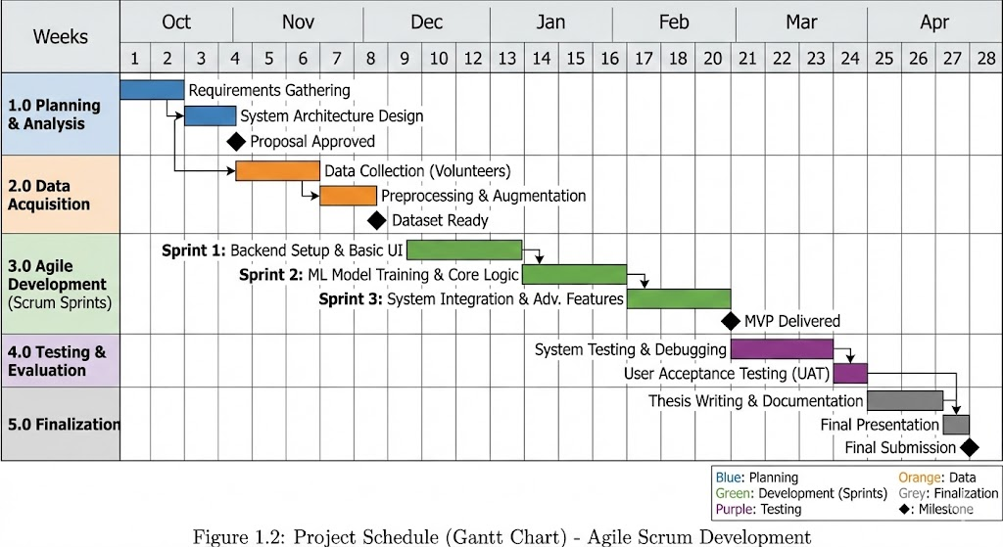 Figure 1.1: gantt chart

PERT Chart for AI-based Face Recognition Project
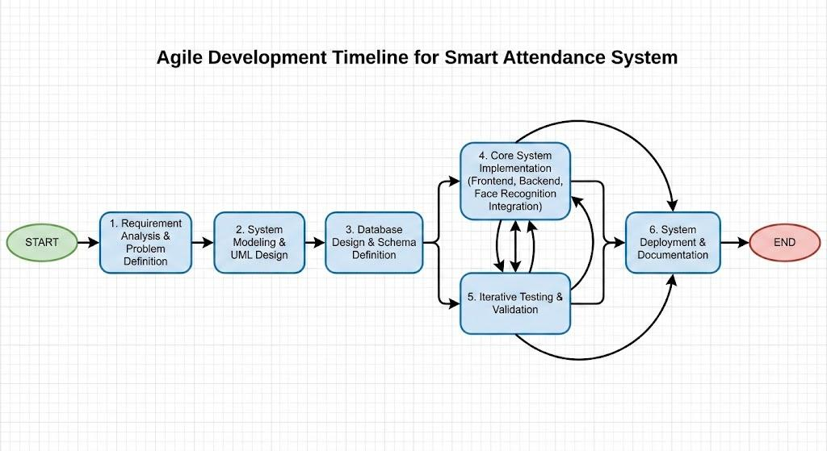
Figure 1.2: Pert chart

1.7.2 Project Budget (Cost Breakdown Estimation)
A sample budget allocation for the project might include:
Cost Category | Item Description | Estimated Cost (ETB)
Hardware | High-Performance Laptop (for model training) | 60,000 ETB
Hardware | External HD Webcam (720p+) | 20,000 ETB
Software | Development Tools (Python, VS Code, Libraries) | 0 ETB (Open Source)
Connectivity | Internet & Data Package | 300 ETB
Miscellaneous | Documentation & Printing Services | 400 ETB
Total | Grand Total | 80,700 ETB

Table 1.3: Project Budget

1.7.3 Project Work Breakdown Structure (WBS), Responsibility, and Deliverers
The project is divided into the following components:

WBS ID | Task Phase | Responsibility | Deliverables
1.0 | Data Collection | Bekam, Bacha | Complete Facial Dataset
1.1 | Dataset Acquisition | Bekam | Raw video footage of 19 volunteers.
1.2 | Preprocessing & Augmentation | Bacha | Cleaned, aligned, and augmented image set (3,800+ images).
2.0 | System Analysis & Design | Bekam, Bacha | Design Specifications
2.1 | Requirement Elicitation | Bekam | Documented functional & non-functional requirements.
2.2 | Architecture Design | Bacha | System flowcharts, UML diagrams, and database schema.
3.0 | System Development | Bekam, Bacha | Functional Prototype
3.1 | Face Detection Module | Bekam | Integrated MTCNN for real-time face detection.
3.2 | Recognition Engine | Bacha | Custom-trained InsightFace model for identification.
3.3 | Frontend UI Development | Bekam | React-based dashboards for Admin, Instructor, and Student.
3.4 | Backend & Database | Bacha | Flask API endpoints and optimized MySQL database.
4.0 | Testing & QA | Bekam, Bacha | Test Reports
4.1 | Unit & Integration Testing | Bacha | Verification of individual modules and API connectivity.
4.2 | User Acceptance Testing | Bekam | Feedback from pilot tests with instructors and students.
5.0 | Deployment | Bekam, Bacha | Final System
5.1 | Documentation & Support | Bacha | User manuals and technical maintenance logs.

Table 1.4 project work breakdown structure

1.7.4 Risk Analysis, Identification, Mitigation and Monitoring
The risk analysis helps in identifying potential issues that could impact the project’s success. Below are the identified risks, their potential impacts, and mitigation strategies:
Risk Factor | Potential Impact | Mitigation Strategy | Risk Factor
Data Privacy & Ethics | Unauthorized access to student biometric data could lead to ethical violations or legal non-compliance. | Implement strict data anonymization (replacing names with codes), secure storage encryption, and obtain explicit informed consent from all volunteers. | Data Privacy & Ethics
Recognition Failure | Poor accuracy due to lighting changes or partial occlusions (masks/glasses) may reduce system reliability. | Train the model with a diverse dataset including augmented images (brightness adjustments, rotations) and establish a confidence threshold of 80% to filter weak matches. | Recognition Failure
Hardware Malfunction | Failure of the primary training laptop or camera could halt development and testing progress. | Maintain backup hardware (secondary laptop and webcam) and use cloud-based repositories (GitHub) to ensure code is never lost. | Hardware Malfunction
Schedule Overruns | Unforeseen technical bugs could delay the project beyond the academic deadline. | Adhere to the Agile Scrum framework with 2-week sprints and set clear "Definition of Done" criteria for every milestone to track velocity. | Schedule Overruns
Dataset Bias | The model may perform poorly on specific demographics if the training data is not sufficiently diverse. | Actively monitor the "False Negative" rate across different student groups and retrain the model with additional samples if bias is detected. | Dataset Bias
Data Privacy & Ethics | Unauthorized access to student biometric data could lead to ethical violations or legal non-compliance. | Implement strict data anonymization (replacing names with codes), secure storage encryption, and obtain explicit informed consent from all volunteers. | Data Privacy & Ethics
Recognition Failure | Poor accuracy due to lighting changes or partial occlusions (masks/glasses) may reduce system reliability. | Train the model with a diverse dataset including augmented images (brightness adjustments, rotations) and establish a confidence threshold of 80% to filter weak matches. | Recognition Failure

Table 1.5 Risk Analysis, Identification, Mitigation and Monitoring

1.8 Feasibility of the Project
The feasibility analysis evaluates the project's viability across economic, technical, schedule, and operational dimensions, confirming that the system can be successfully developed and deployed within the given constraints.

1.8.1 Economic Feasibility
The project demonstrates high economic feasibility due to its strategic reliance on open-source technologies and existing infrastructure.
- Zero Licensing Costs: The core technology stack comprising Python, OpenCV, PyTorch, Flask, and MySQL is open-source, eliminating the need for expensive commercial software licenses.
- Hardware Utilization: The development leverages existing commercial off-the-shelf (COTS) hardware (standard laptops and webcams), removing the need for specialized proprietary equipment. Institutional resources, including laboratory access and internet connectivity, were utilized to further minimize capital expenditure.
- Low Operational Cost: The system is designed to run on standard computing resources available in most Ethiopian universities, ensuring that implementation and maintenance costs remain negligible for the target institutions.

1.8.2 Technical Feasibility
The system is technically sound, built upon proven deep learning architectures that are widely supported in the developer community.
- Proven Technology: The integration of PyTorch and InsightFace ensures robust performance for facial recognition tasks. These libraries are optimized for efficiency, allowing the model to perform real-time recognition on standard CPUs without requiring high-end dedicated GPUs.
- Transfer Learning: By utilizing pre-trained architectures like InceptionResnetV1 and fine-tuning them with a locally collected dataset, the system achieves high accuracy for Ethiopian facial features while keeping computational requirements manageable.
- Scalability: The modular architecture (separating the React frontend from the Flask backend) ensures that the system can be technically scaled or migrated to cloud servers if future demand increases.

1.8.3 Schedule Feasibility
The project is strictly adhering to a defined timeline of 5 to 7 months, managed through the Agile methodology.
- Structured Phases: The Work Breakdown Structure (WBS) clearly delineates phases for Data Collection, Model Training, System Integration, and Testing, ensuring no tasks overlap detrimentally.
- Progress Monitoring: adherence to the schedule is verified through weekly sprint reviews and milestone tracking (e.g., Gantt chart milestones). This proactive management ensures that critical dependencies are met on time, mitigating the risk of project delays.

1.8.4 Operational Feasibility
The system is designed for seamless integration into the existing academic environment with minimal disruption to daily workflows.
- User Adoption: The user interface is intuitive and mimics standard web applications, requiring minimal training for instructors and administrators to master.
- Workflow Alignment: The process mirrors the traditional attendance logic (marking presence/absence) but automates the data entry, making it an enhancement rather than a radical change in procedure.
- Deployment Potential: Initial testing with local student data has demonstrated the system's reliability. Its standalone nature means it can be piloted in individual departments before a college-wide rollout, allowing for a phased and manageable adoption strategy

CHAPTER TWO

STUDY OF EXISTING SYSTEM

2.1 Introduction
This chapter analyzes the current attendance management practices within the university and evaluates various identity verification methods used in educational settings. Given that the proposed project aims to implement a facial recognition-based attendance system tailored for Ethiopian students, it is essential to understand the operational limitations of traditional methods. By examining existing procedures and reviewing relevant literature, this study identifies critical inefficiencies in manual tracking such as time consumption and data inaccuracy while highlighting valuable practices that should be retained. This analysis serves as the foundation for designing a more secure, efficient, and automated solution.

2.2 Literature Review
Attendance tracking methodologies have evolved significantly, yet manual roll calls remain the predominant method in many institutions. While simple to implement, research indicates that manual systems are inefficient and prone to "proxy attendance," where students sign in for absent peers (Patel & Shah, 2018) .
To address these issues, some institutions have adopted Radio Frequency Identification (RFID) card systems. While faster than roll calls, RFID systems are vulnerable to misuse, as students can easily exchange cards to falsify attendance. Furthermore, the implementation costs for card readers and physical infrastructure can be prohibitive for resource-constrained schools (Raza et al., 2019)
Biometric solutions, particularly fingerprint scanners, offer higher security by using unique biological traits. However, contact-based systems pose hygiene risks a significant concern following the COVID-19 pandemic and often suffer from slow processing speeds during peak class hours (Zhong et al., 2020)
Facial recognition technology has emerged as a superior alternative, offering a contactless, automated, and rapid verification process using computer vision. Recent studies demonstrate its potential to significantly reduce administrative workload (Jadhav & Patil, 2021). However, a critical gap exists: many standard algorithms exhibit racial bias, performing with lower accuracy on darker skin tones due to underrepresentation in global training datasets (Buolamwini & Gebru, 2018). This project addresses this limitation by training a custom model specifically on Ethiopian facial datasets to ensure equitable and accurate performance

2.3 Description of the Existing System
The attendance system currently used in many Ethiopian schools and universities, including our institution, is fully manual and paper-based. While simple, it suffers from many operational challenges.

2.3.1 Attendance Process Overview
The current system relies entirely on manual, paper-based procedures involving the following workflow:
- Roll Call: The instructor verbally calls student names at the start of class.
- Verification: Students respond verbally to confirm presence.
- Recording: The instructor manually marks "Present" or "Absent" on a printed sheet.
- Submission: At the end of the month or semester, the attendance sheets are physically submitted to the Department Head for verification and filing

2.3.2 Roles and Responsibilities
The operation of the existing manual system relies on the following key roles:
- Instructors: Responsible for conducting the verbal attendance verification, marking the physical register, and submitting the finalized sheets to the department.
- Students: Required to be physically present to verbally confirm their attendance when called during the session.
- Department Head: Responsible for receiving, verifying, and archiving the physical attendance records submitted by instructors for academic accountability.
- Administrative Staff: Handles the manual data entry of records into the institution's digital system and generates periodic attendance reports.

2.3.3 Time and Efficiency Analysis
The manual attendance process is inherently labor-intensive. Observations indicate that the verbal verification process consumes approximately 5–10 minutes of every instructional session. This significantly reduces effective teaching time. Additionally, the subsequent manual transfer of physical records to the Department Head creates administrative bottlenecks and delays in data digitization

2.3.4 Accuracy and Reliability
Manual systems are inherently prone to:
- Human Error: Instructors may inadvertently mark the wrong student present, particularly in large lecture halls or noisy environments.
- Proxy Attendance: The lack of biometric verification allows students to easily answer on behalf of absent peers ("buddy punching"), compromising the integrity of attendance records

2.3.5 Data Security and Privacy
Physical attendance sheets lack adequate security measures. These documents are often left accessible on desks or in unlocked filing cabinets in the Department Office, making them vulnerable to unauthorized viewing, alteration, or loss due to environmental factors (e.g., fire or water damage) .

2.3.6 Technological Infrastructure
Most classrooms do not use technology for attendance. Even in universities with some IT tools, attendance is still done manually, showing limited modernization.

2.4 Drawback of the Existing System
The current system is slow, taking several minutes each session and reducing teaching time. It is also vulnerable to cheating because students can answer for absent classmates. Human errors are common, especially in noisy or crowded classrooms, and late students are often marked absent unfairly. Paper sheets may be lost or damaged, and reporting delays prevent real-time tracking. Overall, the system increases workload for teachers and administrative staff and does not provide reliable data.

2.5 Practice to be Preserved from the Current System
Although the manual system is being replaced, certain operational requirements remain valid and have been integrated into the new automated solution:
- Instructor Authority: The fundamental rule that the instructor is the sole authority responsible for validating and finalizing attendance records is preserved in the system's role-based access control.
- Periodic Reporting: The requirement to generate consolidated attendance reports at the end of the month or semester for academic review is retained, though the generation process is now automated.

2.6 Business Rules
To ensure smooth operation, the smart attendance system follows these rules:
- All students must be registered with facial data before the system can identify them.
- Each student should be marked present only once per session.
- Facial data and student information must be securely stored and accessed only by authorized personnel.
- Attendance data updates in real time and is saved automatically.

2.7 Alternative Solutions
Before selecting facial recognition, several options were evaluated. ID card systems were considered but were vulnerable to sharing and required hardware costs. Fingerprint scanners were accurate but slow and raised hygiene concerns. QR code systems depended on smartphones and could be misused. A partially digital manual system still retained problems like cheating and time consumption. Facial recognition was chosen because it is contactless, fast, secure, and more accurate when trained with local face data.

2.8 Forms Used
To support the smooth operation of the smart attendance system, a few simple digital forms are used for data collection, corrections, and record-keeping. These forms help ensure proper registration, handle attendance errors, and maintain accurate and secure records.

Main Forms and Their Purpose:
- Student Registration Form:
Used to collect student details and facial images when adding new users to the system.
- Consent Form:
Obtains permission from students (or guardians) to collect and use their facial data ethically and securely.
- Attendance Correction Form:
Allows teachers to manually update attendance if the system fails to recognize a student correctly.
These forms are designed to be simple, digital, and user-friendly, with paper backups available if needed.

Chapter Three

THE PROPOSED SYSTEM

3.1 Overview of the Proposed System
The Smart Attendance System using face recognition is a web-based application designed to automate the attendance process using real-time facial recognition. Unlike the manual method, this system operates on a Client-Server architecture, integrating a React frontend for user interaction and a Flask backend for biometric processing.
The core functionality relies on the InsightFace library (using MTCNN for detection and InceptionResNetV1 for embedding extraction) to verify student identities against a pre-trained dataset of Ethiopian faces. The system adheres to strict operational rules:
- Registration Prerequisite: Attendance cannot be marked for unregistered students; a valid face embedding must exist in the database.
- One-Session-One-Mark: To prevent duplicate entries, a student is marked "Present" only once per active session.
- Automated Closure: When an instructor stops a session, all unrecognized students are automatically marked "Absent" by default.
- Report-Based Correction: While the system automates real-time logging, instructors retain authority by exporting final reports (CSV/Excel) to manually adjust records for late arrivals or technical exceptions offline

3.2 System Constraints
The system operates effectively within certain technical and operational limitations. Understanding these constraints helps set realistic expectations and guides future improvements.

Key System Constraints
Data Quality
System accuracy depends heavily on the training data. We used 200 clear images per student from different angles. Poor-quality images may cause misidentification or rejections.
Hardware Limitations
The backend requires at least an Intel i5 CPU, 8 GB RAM, and a 720p webcam. Lower hardware may slow down processing and reduce stability.
Lighting and Environment
Performance decreases under poor lighting, incorrect camera placement, or crowded backgrounds. Best results occur with eye-level camera positioning and good lighting.
Scalability
The current setup supports about 100 students per section and up to 5 simultaneous sessions. Larger datasets may require database indexing and improved server capacity.
User Cooperation
Accurate recognition requires students to face the camera, maintain the right distance, and avoid covering their faces. Lack of cooperation increases failed attempts.
Privacy and Security
User data is protected using bcrypt hashing, JWT authentication, encrypted embeddings, and strict role-based access. SQL injection is prevented through parameterized queries, and access logs track all changes.
Technical Interruptions
Issues such as power loss, poor network, or camera failure may interrupt recognition. The system includes manual marking, auto-reconnection, and a working time session reopening feature.

Session Management Rule
To ensure data integrity and alignment with university schedules, the system enforces strict operational time blocks. Attendance sessions can only be activated during the Morning Block (08:30 AM – 12:30 PM) or the Afternoon Block (01:30 PM – 05:30 PM). The system automatically prevents session creation or attendance recording during the lunch break (12:30 PM – 01:30 PM) and outside these defined hours
Browser and Device Compatibility
The system works best on Chrome, Firefox, Edge, and Safari with a minimum 720p webcam. Mobile devices provide partial functionality.

3.3 Functional Requirements
The system’s functional capabilities are categorized by module to define specific behaviors for authentication, attendance processing, and session management.
- Authentication & Security: The system must authenticate Administrators, Instructors, and Students using secure JWT tokens. It must also provide a self-service mechanism for users to reset forgotten passwords via a secure email link.
- Real-Time Attendance: The system must capture video frames and identify students in real-time (less than 3 seconds) using the InsightFace engine. To ensure data integrity, it must prevent duplicate attendance entries for the same student within a single active session.
- Session Management: Instructors must be able to Start and Stop attendance sessions only within defined Time Blocks (Morning/Afternoon). The system must automatically mark all unrecognized students as "Absent" immediately when a session is finalized.
- Reporting & Verification: Instructors must be able to filter attendance logs by date, course, or section. The system must generate downloadable reports in CSV or Excel formats to allow instructors to perform offline verification and corrections if necessary.
- User Management: Administrators are authorized to manage student records; however, the system must restrict the final creation of new student profiles until the required biometric data (video footage) has been collected, processed, and successfully embedded into the recognition database.

3.4 Non-Functional Requirements
These requirements define the system's operational standards for performance, security, and reliability in an academic setting.
- Performance: The facial recognition engine processes video input and returns identification results within 1–3 seconds per student, ensuring a smooth flow during classroom entry.
- Accuracy: To minimize false identifications, the system enforces a strict confidence threshold of 80%. Matches below this value are automatically rejected to maintain a False Positive Rate (FPR) of less than 1%.
- Availability: While the administrative dashboard is accessible 24/7, the attendance recording module is strictly limited to defined academic hours (08:30 AM–12:30 PM and 01:30–05:30 PM). It automatically locks during lunch breaks and off-hours to prevent unauthorized use.
- Security & Privacy: User passwords are protected using Bcrypt hashing. Student facial biometrics are stored exclusively as encrypted numerical embeddings not as raw images ensuring the data cannot be reconstructed or misused.
- Reliability & Recoverability: The model utilizes augmented training data to maintain accuracy across variable lighting conditions. Additionally, the system safeguards data integrity by retaining logged attendance records during temporary network failures or browser crashes.
- Usability: The interface features a simplified workflow, allowing new instructors to master the session management process with less than 15 minutes of training.
- Compatibility: The application is fully web-based and functions on standard modern browsers (Chrome, Edge, Firefox), eliminating the need for specialized client-side software installation .

3.5 Graphical User Interface (GUI)
The GUI is designed to be responsive, intuitive, and strictly role-based. It employs a dashboard-driven layout to minimize navigation latency and maximize the visibility of real-time attendance data.

3.5.1 Interface Features
The system features four primary functional modules designed for specific user roles:
- Secure Login Portal: Provides a unified entry point with role-based redirection (Admin, Instructor, Student) and JWT authentication.
- Administrator Dashboard: Serves as the central control hub, offering tools for user management, system health monitoring, and global data export.
- Instructor Dashboard: A class-specific workspace featuring the Live Camera Panel for real-time attendance tracking (active only during valid Time Blocks) and a Report Viewer for generating CSV/Excel logs.
- Student Portal: A read-only interface allowing students to track their personal attendance history and view performance statistics .

3.5.2 User Interface Layout
The interface design prioritizes usability and responsiveness through the following layout strategies:
- Dashboard-Driven Architecture: Utilizes a sidebar navigation layout to allow quick access to key modules without cluttering the main workspace.
- Real-Time Visual Feedback: The Camera Feed Panel and Attendance Panel are positioned prominently to provide immediate visual cues (e.g., green borders or "Face Detected" alerts) during the recognition process.
- Role-Based Isolation: Views are strictly segmented; administrative controls are hidden from instructors, and modification tools are hidden from students to ensure operational security .

3.5.3 Interface Snapshots (Prototype)
This section presents the key GUI views developed for the system. A secure entry screen featuring input validation and a "Forgot Password" workflow.

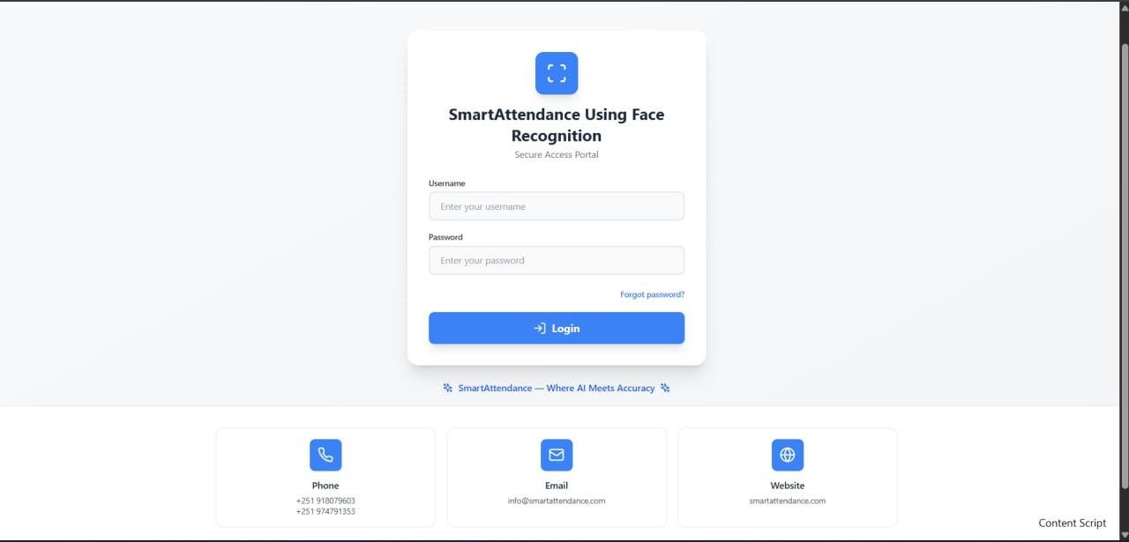

Image 3.1 smart attendance system log in page
Admin Dashboard: A sidebar-driven interface for managing users, training models, and viewing system logs.
Instructor Dashboard: Displays the live camera feed and recent check-ins, allowing instructors to monitor class attendance in real-time.
Student Dashboard: A personalized view showing attendance percentages and historical records to help students track their academic standing

CHAPTER FOUR

SYSTEM MODELING

4.1 Introduction
System modeling provides a structured approach to representing the architecture, behavior, and interactions of the Smart Attendance System. This chapter applies Unified Modeling Language (UML) standards to describe system functionality through actor identification, use case analysis, and interaction modeling. The objective is to clearly explain how users interact with the system and how functional requirements are realized.
The Smart Attendance System involves three primary actors: Administrator, Instructor, and Student. Each actor has a distinct role, responsibility set, and access level. By identifying these actors and their associated use cases, this chapter validates system requirements, supports design decisions, and ensures alignment with user needs.

4.2 Actor Identification
Actor identification is an essential step in system modeling because it defines who interacts with the system and what actions they can perform. In the Smart Attendance System, actors are categorized by their roles and permissions, which determine how they access and use system features.

4.2.1 List of Actors
The Smart Attendance System has three primary actors:

1. Administrator
Role: System administrator and supervisor
Responsibilities:
- Log in to the system dashboard
- Add and manage instructor accounts (username, password, email, assigned course,session type, academic year and section)
- View pre-registered student lists across all section
- Manage student accounts, including disabling students when required, change password,name,email, year, section and department of student
- Download and export overall attendance record history (limited analytical functionality)
- Manage attendance sessions at a supervisory level Access Level: Full system access with limited reporting functionality

2. Instructor
Role: Attendance session controller and report generator
Responsibilities:
- Log in to the instructor dashboard
- Create new attendance sessions(chose morning and afternoon with working time, select session type,course assigned by admin)
- Reopen previously created sessions when needed
- Record attendance
- End daily attendance sessions(stop camera)
- Close semester-level attendance sessions after 4–5 months with at least 8 attendance sessions
- Generate detailed attendance reports (daily, weekly, monthly,semester, yearly, by course, or by section) and View records
- Change password
- Access Level: Access limited to assigned courses and section

3. Student
Role: Attendance participant and viewer
Responsibilities:
- Log in to the student dashboard
- View personal profile information
- View attendance status indicators (e.g., good standing or warning)
- View records of present and absent sessions filter by course and instructor
- Access Level: Read-only access to personal attendance data

4.3 Use Case Identification
Use cases describe what each actor wants to accomplish through the system. They represent the system’s functional requirements from the user’s perspective. The following use cases are identified for each actor.

Administrator Use Cases
- Log in to the system
- Manage instructors (add, edit, disable, )
- Manage students (disable and edit) and View pre-registered student lists
- View all attendance records
- Export attendance data (CSV/Excel)
- View system statistics and usage
- Manage user accounts and reset passwords

Instructor Use Cases
- Log in to the system
- Create a new attendance session
- Start camera for live recognition
- Record attendance automatically
- Stop camera and mark remaining students absent
- Reopen session on working hours(morning and afternoon)
- End session permanently at semester completion
- View real-time session attendance
- View historical attendance records
- Generate attendance reports
- Export reports (CSV/Excel)

Student Use Cases
- Log in using student credentials
- View personal attendance history
- Filter attendance by course or instructor
- View attendance statistics (present/absent counts, percentages)
- Request password reset through email

4.4 System Use-Case Diagram
The use case diagram provides a visual representation of the system's functionality and the interactions between actors and use cases. It illustrates the relationships between different actors and the functions they can perform within the system.

4.4.1 Actor Description
No. | Actor/Component | Description
1 | Student | Marks attendance through face recognition.
2 | Instructor | Views, monitors, and generates attendance reports for their students.
3 | System Administrator | Manage users and Views records

Table 4.1: List of Actors and Their Description

4.4.2 Use-Case Description
Use Case | Description | Actors Involved
Login | Authenticate users (instructor, student or admin) based on role. | Instructor, Administrator, Student
Logout | End session securely. | Instructor, Administrator ,Student
Take Attendance | Records attendance automatically when a student stands before the camera. | Instructor, Student
Generate Attendance Reports | Generate attendance reports by date, student, or class. | Instructor,
Monitor Attendance | View real-time student attendance. | Instructor(own),Administrator and Student(own)
Manage User Accounts | Add/edit/disable and enable user accounts. | Administrator

Table 4.2: Use-Case Description
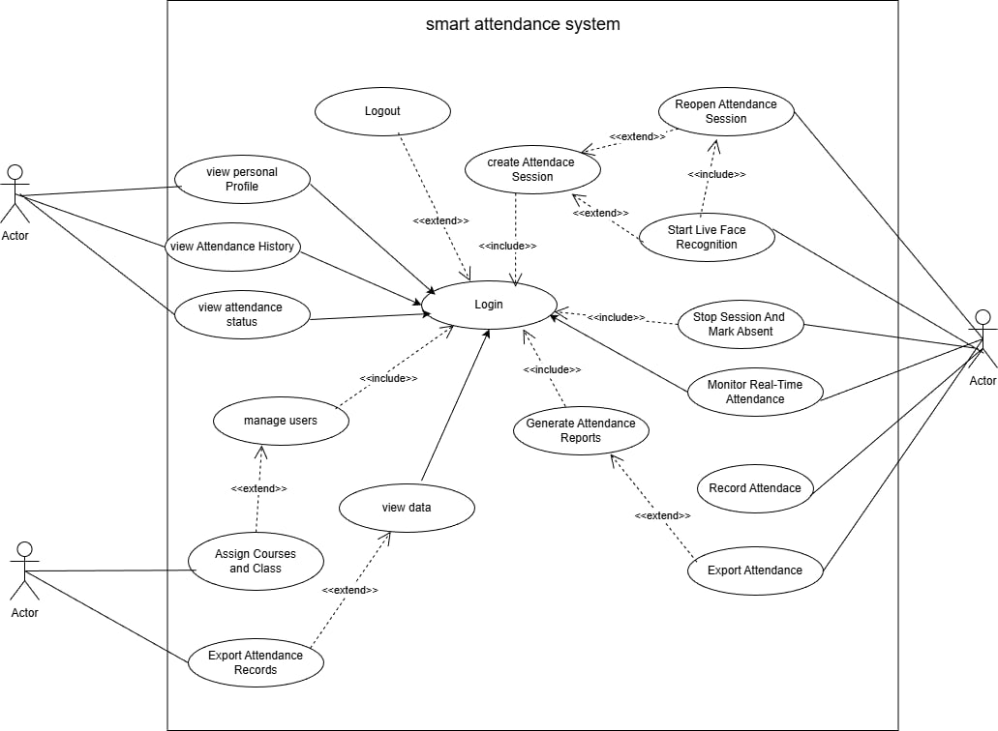

Figure 4.1: Use case diagram

4.5 Dynamic Modeling
Dynamic modeling illustrates the runtime interactions between the system's core components: the React frontend, Flask backend, MySQL database, and the InsightFace recognition engine. This section details the message flows for attendance marking, session management, and administration.

4.5.1 Sequence Diagram
This sequence diagram illustrates the chronological interaction and message exchange between all system actors (Student, Instructor, and Administrator) and the core system components during the attendance process. It demonstrates how attendance is captured, processed, stored, and made available to authorized users.
- A Student positions themselves within the field of view of the camera during an active attendance session.
- The Camera module captures a video frame and forwards it to the Attendance Controller.
- The Attendance Controller transmits the captured frame to the Face Recognition Engine via an internal API.
- The Face Recognition Engine detects the face, extracts facial embeddings, and compares them with stored student data in the Attendance Database.
- If a valid match is found, the system logs the attendance status and timestamp in the database.
- The Instructor Dashboard receives real-time attendance updates for session monitoring.
- The Student Dashboard displays confirmation of attendance and updated attendance status.
- The Administrator Dashboard accesses attendance records for system monitoring and data export purposes.
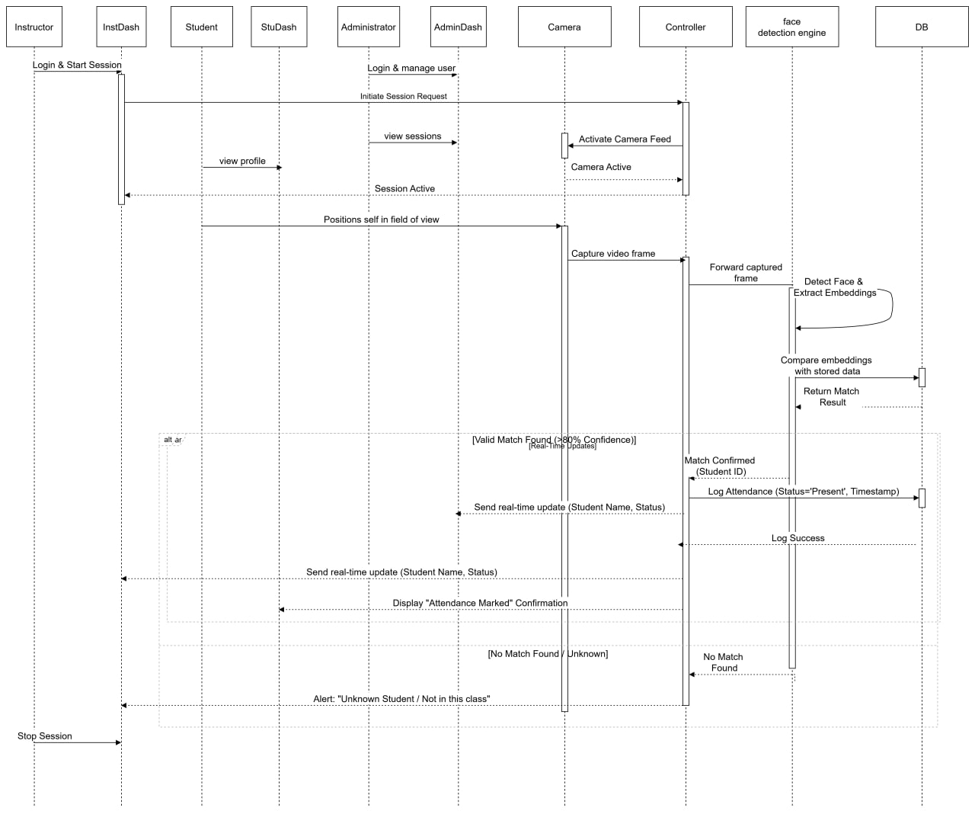

Figure 4.2: Sequence Diagram for all actors

1. Instructor sequence diagram
The instructor sequence diagram illustrates the interaction between the Instructor and system components during attendance session management and report generation. It focuses on the ordered exchange of messages required to initiate sessions, monitor attendance, and generate reports.
- The Instructor logs in to the dashboard by submitting authentication credentials.
- The system validates the credentials and grants access to the instructor interface.
- The Instructor initiates a new attendance session or reopen an existing session.
- The system activates the recognition service and updates attendance records in real time.
- The system retrieves attendance data from the database.
- The Instructor generates and downloads attendance reports in CSV or PDF format
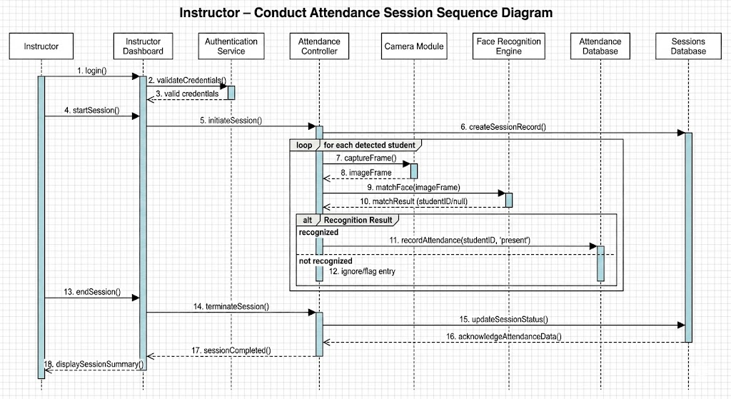
Figure 4.3: Sequence Diagram for instructor

2. System Administrator sequence diagram
The system administrator sequence diagram illustrates the ordered interaction between the Administrator and system components for system supervision, user management. The diagram focuses on administrative control and monitoring.
- The Administrator logs in to the admin dashboard by submitting authentication credentials.
- The system validates the credentials and grants access to the administrative interface.
- The Administrator manages instructor accounts by creating new profiles, updating existing information, and assigning courses or departments.
- The Administrator manages student accounts, including enabling or disabling users.
- The Administrator monitors active attendance sessions and reviews historical session records.
- The Administrator requests system-wide attendance data and exports available records for institutional use.
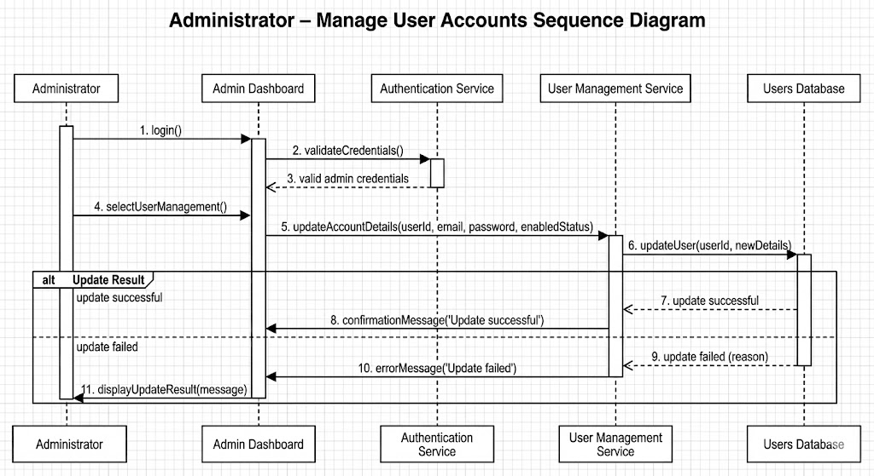

Figure 4.4: Sequence Diagram for System Admin

3. Student sequence diagram
The student sequence diagram illustrates the interaction between the Student and system components during automated attendance capture and attendance status verification. The diagram emphasizes that attendance marking is performed automatically by the system without manual input from the student.
- The student logs in through the student dashboard.
- The system authenticates the student using the database.
- If authentication fails, a login error is displayed.
- If authentication succeeds, the system retrieves attendance records.
- The student dashboard displays the attendance status.
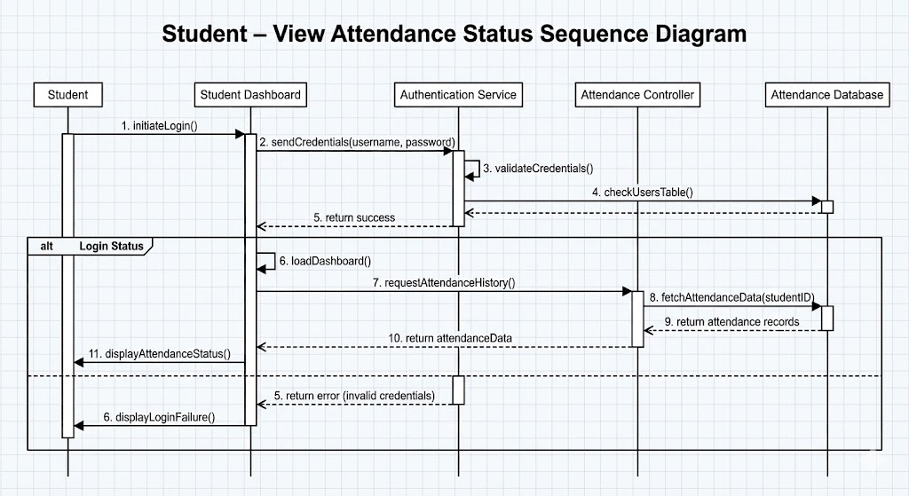
Figure 4.5: Sequence Diagram for student

4.5.2 Collaboration Diagram
The collaboration diagram (also known as a communication diagram) illustrates the runtime interactions and message exchanges between system components involved in the attendance process. It emphasizes how different objects collaborate to achieve automated attendance recording rather than detailing internal algorithms or user workflows.
The diagram illustrates the following key interactions:
- Student Interaction: The student appears in front of the camera during an active session. The camera module captures a video frame and sends the image to the recognition engine.
- Biometric Processing: The recognition component detects the face, extracts facial embeddings, and compares them with stored biometric templates in the database.
- Attendance Logging: When a match is found, the system retrieves the corresponding student identifier and stores the attendance status with a timestamp in the attendance database.
- Instructor Interaction: The instructor accesses the system to monitor real-time attendance records and to request attendance reports after the session ends.
- Administrative Oversight: The administrator interacts with the system for user management, and limited access to overall attendance records.
- This diagram demonstrates how system components collaborate through message passing to ensure accurate and efficient attendance management.

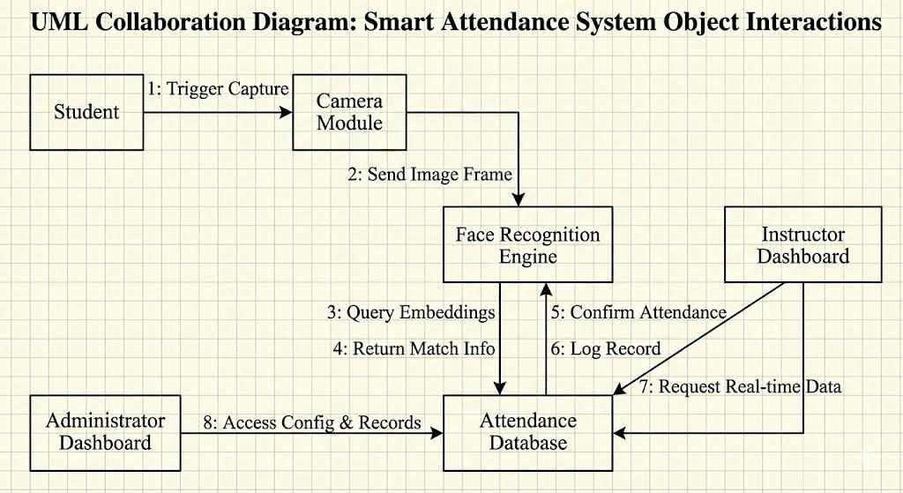
Figure 4.6: Collaboration Diagram

4.5.3 Activity Diagram
The activity diagram outlines the workflow of the Smart Attendance System, starting from system initialization to attendance logging. Users choose between registered or new student modes. Registered students proceed through face capture, embedding, and matching if matched, attendance is logged and the status displayed.
Activity Diagram for Student
- Logs into the student dashboard.
- Views personal profile and attendance status indicators.
- Appears in front of the camera during an active attendance session.
- System captures and verifies the face automatically.
- Attendance is marked as Present if recognition is successful.
- Student views updated attendance records, including present and absent sessions by course.
- Logs out.
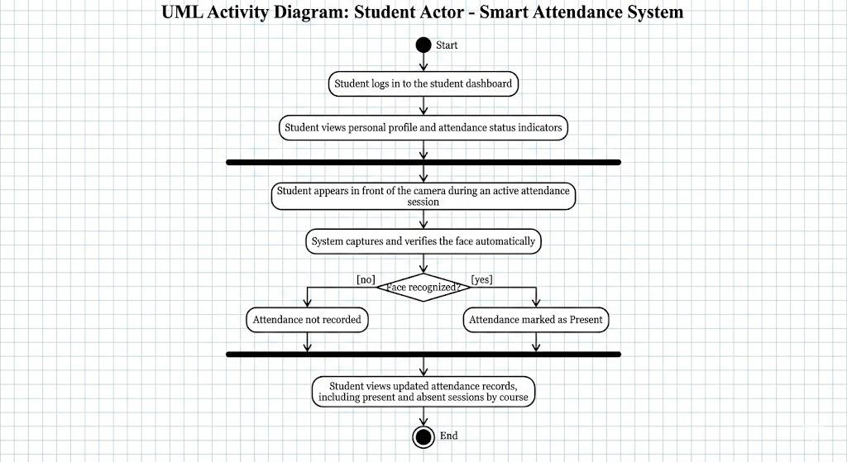
Figure 4.10: Activity Diagram for Student

Activity Diagram for Instructor
- Session Initiation: The Instructor logs in to the dashboard and selects the specific course and section to initialize a new attendance session.
- Real-Time Monitoring: Once the session starts, the Instructor monitors the live interface as the system automatically recognizes students and updates their status to "Present."
- Session Termination: The Instructor stops the session. At this point, the system automatically marks all unrecognized students as "Absent".
- Report Generation: The Instructor generates the final attendance log and downloads it in CSV or Excel.
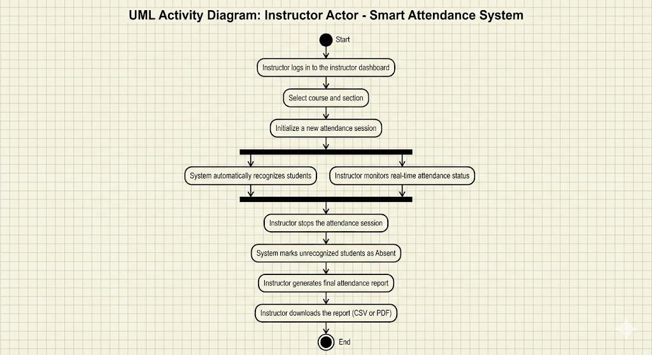
Figure 4.7: Activity Diagram for Student

Activity Diagram for System Administrator
- Logs into the administrator dashboard.
- Adds and manages instructor accounts, including course and class assignments.
- Views pre-registered student lists across all classes.
- Manages student accounts, including disabling students when required.
- Monitors attendance records.
- Downloads or exports overall attendance record history (limited reporting).
- Manages system settings such as recognition thresholds and session parameters.
- Manages attendance sessions at a supervisory level.
- Logs out.
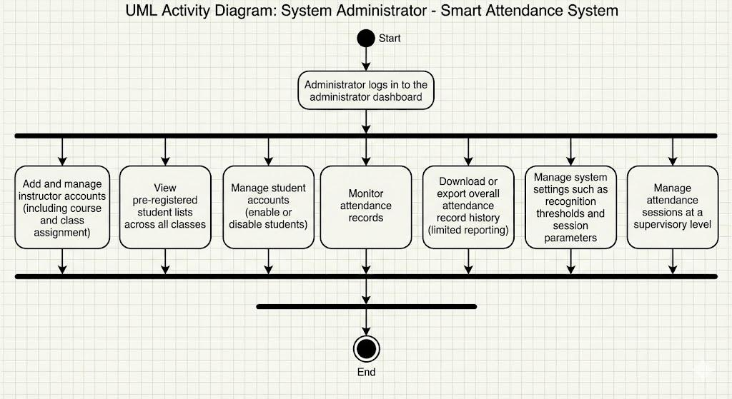
Figure 4.8: Activity diagram for system Admin

4.5.4 State Chart Diagram
The state chart diagram models the dynamic lifecycle of the attendance process, illustrating the transitions between distinct system states triggered by external events. It provides a granular view of how the system reacts to student interaction and internal processing outcomes.
- Idle State: The system remains in a standby mode, actively monitoring the camera feed for input.
- Detection State: Upon detecting a face in the video frame, the system transitions to the detection phase to isolate facial features.
- Processing State: The system generates a facial embedding and compares it against the stored dataset.
- Logging State: If a match is confirmed, the system transitions to the logging state, where the attendance record is committed to the database.
- Confirmation State: Finally, the system displays a success message to the user before reverting to the Idle State to process the next student.

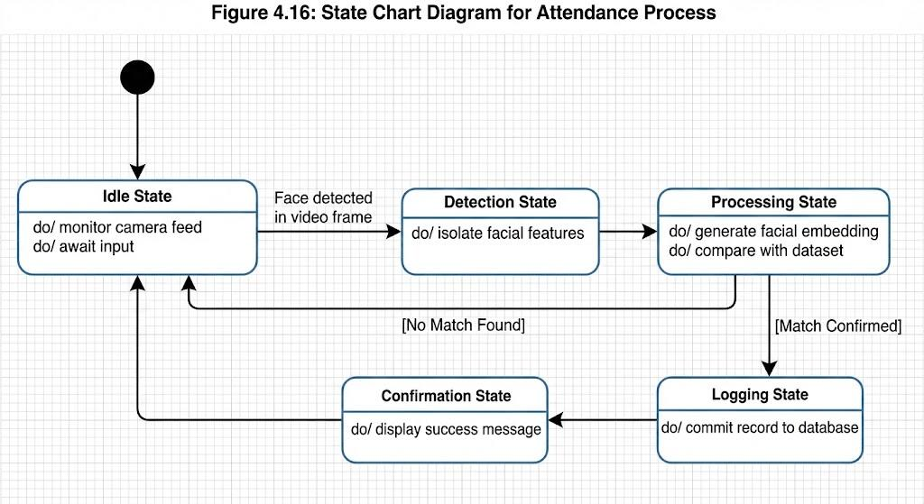

Figure 4.9: State Chart Diagram for all users

4.6 Object Modeling
Object modeling involves creating class diagrams and object diagrams to represent the structure and relationships of objects within a system

4.6.1 Class Diagram
User (Base Class): Handles common authentication data such as usernames and encrypted passwords, serving as the parent class for specific roles.
Admin: A specialized class responsible for high-level system management, including the ability to manage user accounts and system settings.
Student: Stores academic details, including ID and department, along with the pre-loaded facial biometric data used for recognition.
Instructor: Includes the functionality to initiate new attendance sessions and retrieve detailed class analytics and logs.
FaceRecognition: Encapsulates the core artificial intelligence logic, specifically the functions required for detecting faces and matching biometric embedding’s.
AttendanceRecord: Links a specific student to a session with a precise timestamp and status, ensuring accurate data traceability.
Database: Manages the persistent storage and retrieval of all user profiles, session logs, and attendance records.

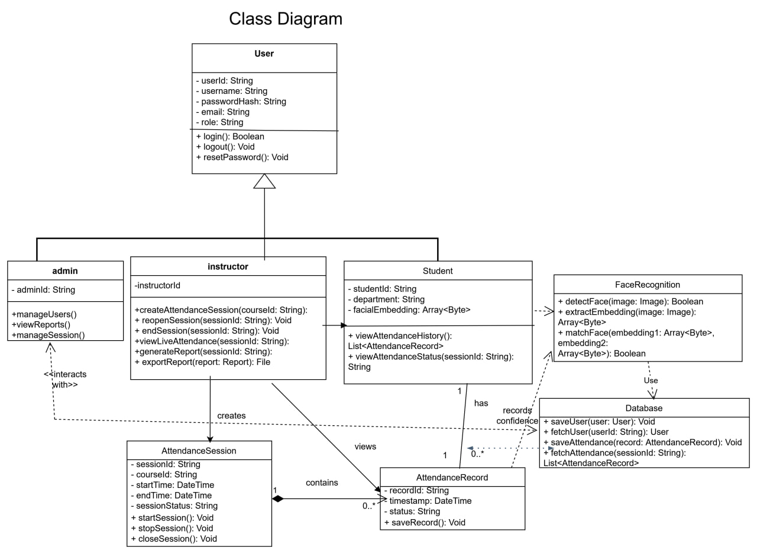

Figure 4.10: Class Diagram

4.6.2 Object Diagram
The Object Diagram provides a concrete, runtime snapshot of the Smart Attendance System. While the Class Diagram defines the static rules, this diagram illustrates how specific instances of these classes interact during a live attendance session to process a single event.
In the scenario depicted, the system successfully logs the attendance of a specific student:
- The Student Instance (student1): Represents an active student entity (e.g., ID STU001, Name "Sara") whose facial embedding’s are already pre-loaded in the system for verification.
- The Camera Object (camera1): An active device configured with specific parameters, such as 720p resolution and a 30 fps frame rate, to capture the video frame.
- The Recognition Engine (faceRec): An instance of the AI logic actively processing the input frame using the loaded CNN model and a strict confidence threshold (e.g., 0.8).
- The Attendance Record (attendanceLog): A newly instantiated log entry that links the specific student instance to the current timestamp with a status of "Present".
- The Database Connection (db): Represents the active persistent storage connection, currently in an "Active" state to commit the new attendance log.
This visualization validates the system's dynamic behavior, confirming that data flows correctly from the physical capture device to persistent storage.

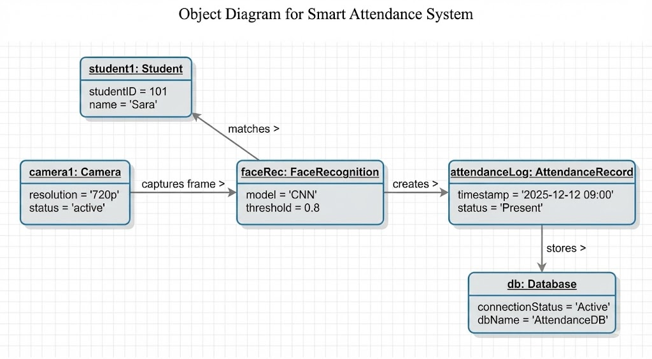
Figure 4.11: Object Diagram

CHAPTER FIVE

SYSTEM IMPLEMENTATION AND ARCHITECTURE DESIGN

5.1 Introduction
This chapter explains how the Smart Attendance System is designed and implemented using AI-based facial recognition. It describes how the frontend, backend, and machine learning components work together to form a complete and reliable solution. The system is optimized for real-time recognition, low hardware usage, and high accuracy. It integrates MTCNN for face detection, InceptionResNetV1 for feature extraction, and a custom SVM classifier for student identification, making the architecture suitable for classroom environments.

5.2 Architecture Design
The system uses a three-tier client–server architecture, separating the presentation layer,application logic, and data storage. This structure makes development, testing, and maintenance easier while supporting scalability and security.

1. Presentation Layer (Frontend)
Technology: React + TypeScript
Components: Admin, Instructor, Student dashboards
Functions:
- User login and session handling
- Real-time attendance display
- Report viewing and export
- Communication: REST API (HTTP/HTTPS)

2. Application Layer (Backend)
Technology: Python Flask
Modules:
- JWT authentication
- Face detection and recognition (InsightFace + OpenCV)
- Session management logic
- Report generator
Functions:
- Executes business logic
- Validates data
- Enforces security rules
Communication: Receives requests from frontend, interacts with database

3. Data Layer (Database)
Technology: MySQL
Components: Tables for Users, Students, Sessions, Attendance, and password reset
Functions:
- Stores and retrieves persistent data
- Maintains foreign keys and indexing
- Protects data using bcrypt hashing and parameterized queries

System Workflow
- Image Acquisition: Browser webcam captures video frames using MediaStream API.
- Face Detection: InsightFace locates faces in each frame.
- Feature Extraction: Embeddings are generated as 128-dimensional vectors.
- Recognition: Embeddings are compared with stored student embeddings.
- Validation: System checks section, course, and year.
- Attendance Logging: Attendance is stored with timestamp and confidence score.
- UI Update: Dashboard updates instantly to show newly marked students.
- Data Storage: Records are saved permanently in MySQL.

Key Architectural Features

Modularity
- Frontend and backend work independently
- Separate modules for authentication, recognition, reporting
- Backend uses blueprint routing for clean organization

Scalability
- Supports multiple simultaneous sessions
- Indexed queries for fast access

Security
- JWT tokens with 24-hour expiry
- Role-Based Access Control (RBAC)
- Parameterized SQL queries
- Passwords hashed with bcrypt

Reusability
- Facial embeddings stored once and reused
- Shared authentication module for all roles

Integration
- REST APIs for external system support
- Reports exportable as CSV/Excel
- Email service for password resets

Architectural Goals Achieved
- Reusable models
- Easy integration
- Scalable database structure
- High security
- Maintainable modular design
- 1–3 second recognition speed with real-time UI updates

5.2.1 Component Diagram
The component diagram represents the main building blocks of the system and how they interact.

System Components
- Frontend (React + TypeScript)
  - Admin, Instructor, Student dashboards
  - Login and password reset pages
- Camera Module
  - Captures live images
  - Sends frames to backend every 2 seconds
- Face Detection Module
  - Detects face boundaries
  - Uses InsightFace (with OpenCV fallback)
- Face Recognition Module
  - Extracts embeddings
  - Compares with stored embeddings
  - Returns student name+student ID + confidence score
- Authentication Module
  - Handles login via JWT
  - Hashes passwords using bcrypt
  - Enforces role permissions
- Session Management Module
  - Creates and manages sessions
  - Controls start/stop/reopen
  - Applies working hour time retake rule
- Attendance Logger
  - Stores timestamps
  - Prevents duplicates
  - Marks absentees automatically
- Database Layer (MySQL)
  - Stores Users, Students, Sessions, Attendance,password_reset
  - Applies indexing and constraints
- Report Generator
  - Filters by date, course, or student
  - Exports CSV/Excel
- Email Service
- Sends password reset links
- Generates secure tokens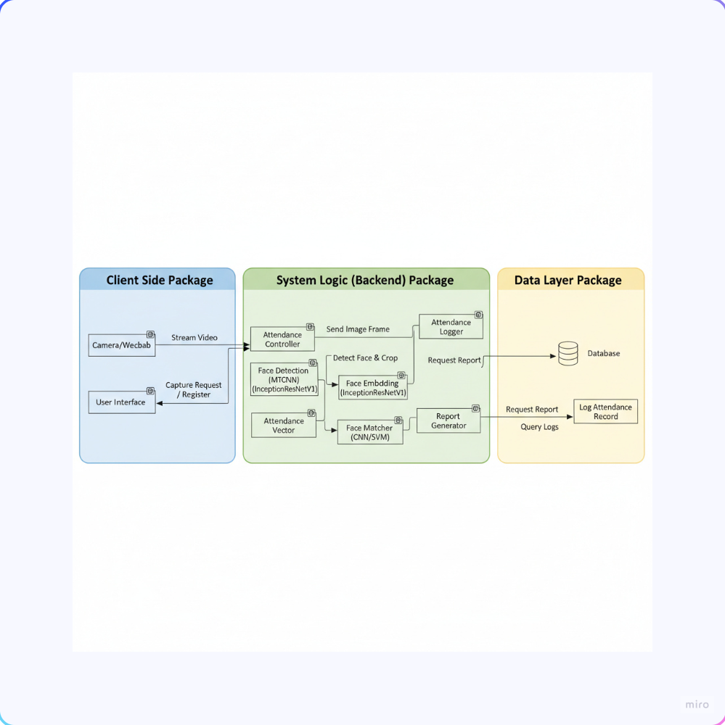

Figure 5.1: Component modeling diagram

5.2.2 Deployment Diagram
This diagram shows how the system runs on different devices and servers using a client–server architecture.

Deployment Architecture
- Client Devices: Laptops/PCs with webcam and browser.
- Web Server: Flask backend handling API requests
- Database Server: MySQL storing all records
- Network: All communication through HTTP/HTTPS

System Requirements
Client Side
- 720p webcam
- Modern browser
- No installation required
Server Side
- Intel i5 CPU, 8–16GB RAM
- 20GB SSD
- Windows, Ubuntu, or macOS

Software Stack
- Frontend: React + TypeScript
- Backend: Python 3.8+, Flask, OpenCV, InsightFace
- Database: MySQL 8.0+

Deployment Options
- Local Network: Hosted internally using local IP
- Cloud Deployment: AWS/Azure for scalability
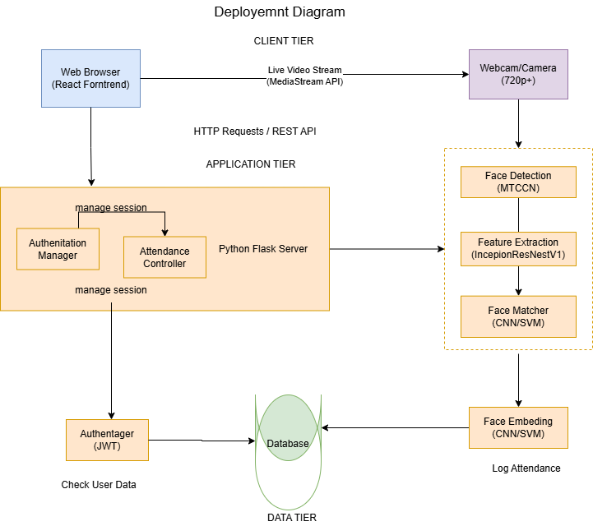

Figure 5.2: Deployment Diagram

5.3 Database Design
The database ensures secure, fast, and structured data handling. MySQL supports relational integrity, indexing, and concurrent access.

Design Principles
- Normalization to reduce redundancy
- Foreign keys for consistency
- Indexing for fast queries
- Bcrypt hashing for password security
- Parameterized queries to prevent SQL injection

Core Database Tables

1. Users Table
Stores login credentials and roles (Admin, Instructor, Student).

2. Students Table
Stores academic details, student ID, department, year, and section.

3. Sessions Table
Stores details about created attendance sessions, timestamps, and status.

4. Attendance Table
Stores individual attendance records with timestamps and confidence scores.
5. Password reset Table
Stores tokens and expiration timestamps for users initiating a password reset.

5.3.1 Entity Relationship Diagram (ERD) Design
The ERD depicts the relationships between various entities within the system:
Entities and Attributes:
- Student: studentID (PK), name, embedding, department
- AttendanceRecord: recordID (PK), studentID (FK), timestamp, status
- Instructor: instructorID (PK), name, email, department, role

Key Relationships
- Users → Students (One-to-One): Each student is linked to a single user account.
- Users → Sessions (One-to-Many): Instructors can create multiple attendance sessions.
- Sessions → Attendance (One-to-Many): Each session contains several attendance records.
- Students → Attendance (One-to-Many): Each student appears in multiple attendance entries over time.

Database Constraints
- Primary Keys: Ensure each record can be uniquely identified.
- Foreign Keys: Maintain consistent relationships between tables.
- Unique Constraints: Prevent duplicate usernames, emails, and student IDs.
- Not Null Constraints: Ensure required fields are always filled.
- Cascade Delete: Automatically removes attendance records when a session is deleted.

Indexing Strategy
- Users Table:
  - username — Speeds up login queries
  - email — Improves user lookup performance
- Students Table:
  - student_id — Enables fast student search
- Sessions Table:
  - instructor_id — Supports quick session filtering
  - status — Improves retrieval of active or past sessions
- Attendance Table:
  - student_id — Speeds up report generation
  - session_id — Helps retrieve session-specific records
  - date — Optimizes date-based reporting
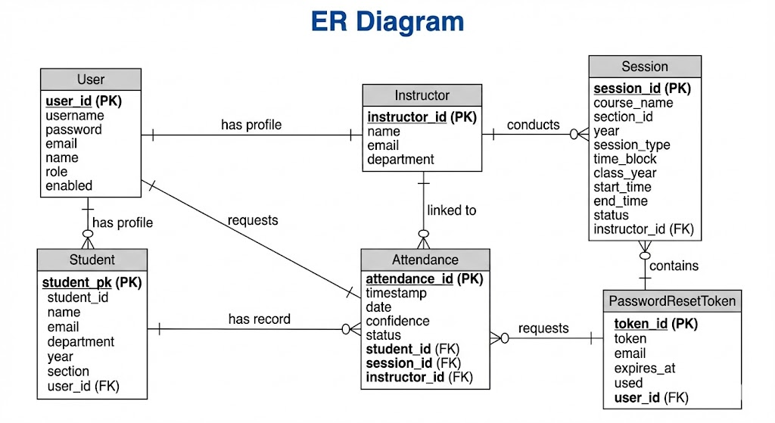
Figure 5.3: ER diagram

5.3.2 Normalization
Normalization was applied to ensure the database is free from redundancy and supports efficient data storage. The process followed the standard normalization steps:
- First Normal Form (1NF): Ensured that each field contains atomic values and no repeating groups.
- Second Normal Form (2NF): Ensured that all non-key attributes are fully functionally dependent on the primary key.
- Third Normal Form (3NF): Removed transitive dependencies; each attribute depends only on the primary key.
1. Unnormalized Form (UNF)
studentID | name | embedding | department | recordID | timestamp | status
101 | Sara | [0.1...] | CS | 1 | ... | Present
102 | John | [0.1...] | CS | 2 | ... | Absent
Table 5.1: Unnormalized Form of student table
First Normal Form (1NF)
Student Table
studenID | name | embeddings | Department
101 | sara | [0.1, 0.2…] | cs
Table 5.2 First Normal Form (1NF)
AttendanceRecord Table
recordID | studentID | timestamp | status
1 | 101 | ……. | present
2 | 101 | …. | absent
Table 5.3 Second Normal Form (2NF)
- Ensure every non-key attribute fully depends on the entire primary key.
- Since primary keys are now simple (e.g., studentID, recordID), and no partial dependencies exist, 1NF = 2NF here.
Third Normal Form (3NF)
Remove transitive dependencies (e.g., department → departmentName, departmentHead).
Students Table
studentID | name | embeddings | departmenID
101 | sara | [0.1, 0.2, …] | D01
Table 5.4 Third Normal Form (3NF)
Departments Table
departmentID | departmentName
D01 | cs
AttendanceRecords Table (same as above)

5.3.3 Persistence Diagram
The persistence diagram shows how the system stores and manages data using MySQL. The database provides ACID support, foreign keys, and indexing to ensure data consistency, fast access, and reliability.
Persistent Data Types:
- User Authentication Data: Stored in the Users table, containing login details, roles, and profiles.
- Student Profiles: Stored in the Students table and kept during enrollment
- Session Data: Stored in the Sessions table, including timestamps and session status.
- Attendance Records: Stored permanently in the Attendance table with timestamps and confidence scores.
Persistence Mechanisms:
Data is saved during registration, session creation, and attendance marking using secure transactions. Retrieval includes login, session lists, and attendance history, while updates handle password reset, session changes, and corrections. Session deletions follow cascade rules.
Data Integrity:
Maintained through primary/foreign keys, unique constraints, not-null fields, and indexed columns to speed up queries.
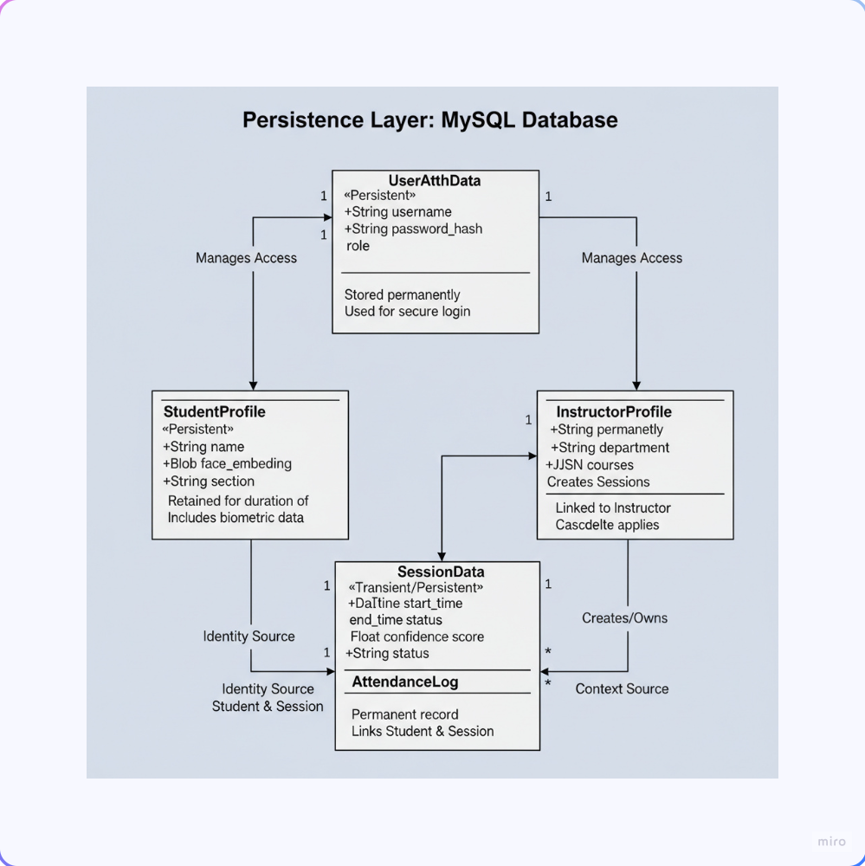
Figure 5:4: Persistence Diagram

CHAPTER SIX

SYSTEM IMPLEMENTATION

6.1 Introduction
This chapter describes how the Smart Attendance System was implemented, tested, and prepared for deployment. The development followed an iterative approach, where each feature was designed, built, and tested step by step. The system uses a web-based architecture: React with TypeScript for the frontend, Flask (Python) for backend logic and face recognition, and MySQL for storing user, session, and attendance data. This chapter also includes UI screenshots and explains the testing strategies used to check correctness, reliability, and performance.

6.2 User Interface Prototype (Screenshots)
The system provides three role-based interfaces: Administrator, Instructor, and Student. All screens are designed to be simple, clean, and easy to use.

6.2.1 Login Page
The login page is the main entry for all users. It includes username and password fields, input validation, error messages, and a password recovery option. The design is responsive for different devices.
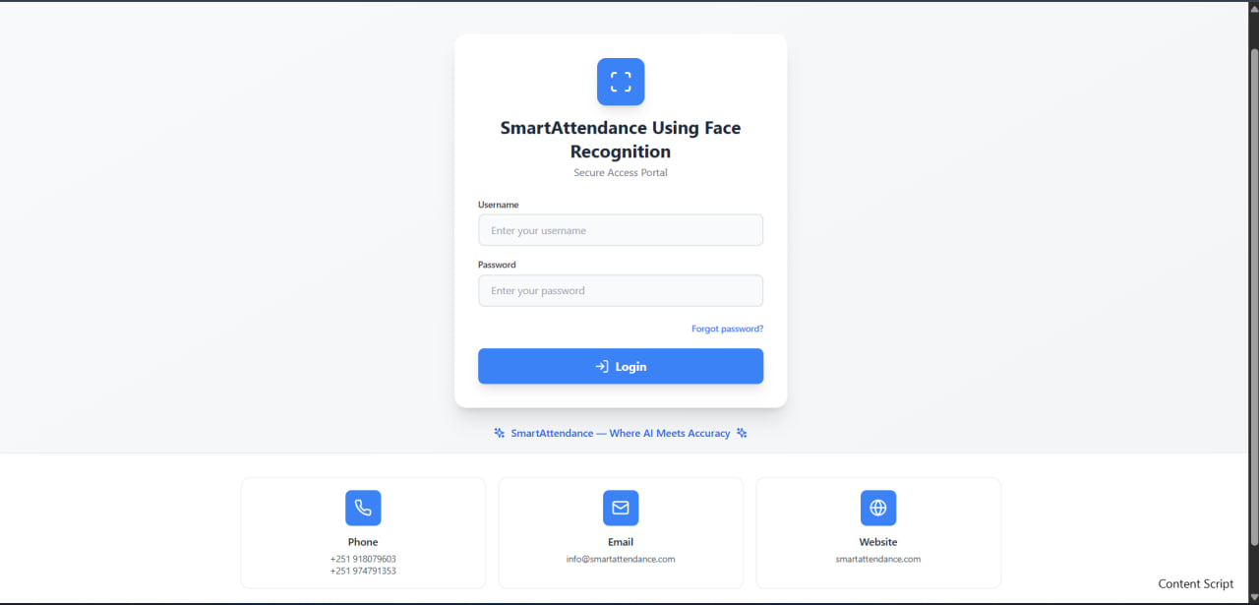
Figure 6.1: Log in page

6.2.2 Administrator Dashboard
The Admin Dashboard manages users, attendance records, system statistics, and reports. Administrators can add or edit users, monitor sessions, and export data in CSV or Excel format.
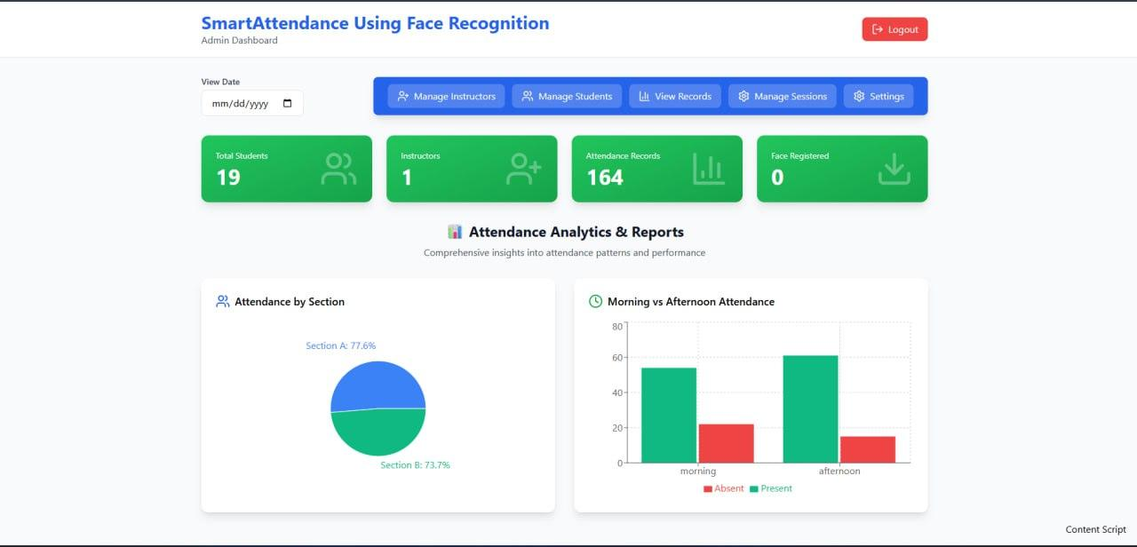
Figure 6.2: Admin Dashboard

6.2.3 Instructor Dashboard
Instructors manage sessions and attendance. They can view all sessions, create new ones, monitor status, edit profiles, and generate reports.
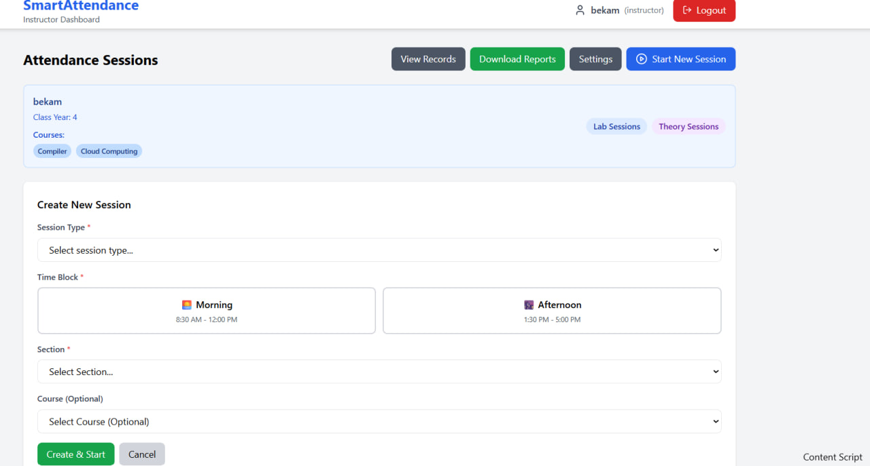
Figure 6.3: Instructor Dashboard

6.2.4 Attendance Session Page (Instructor)
This page handles real-time attendance using face recognition. It shows the camera feed, marks present students automatically, shows confidence scores, and allows instructors to stop or end the session. page.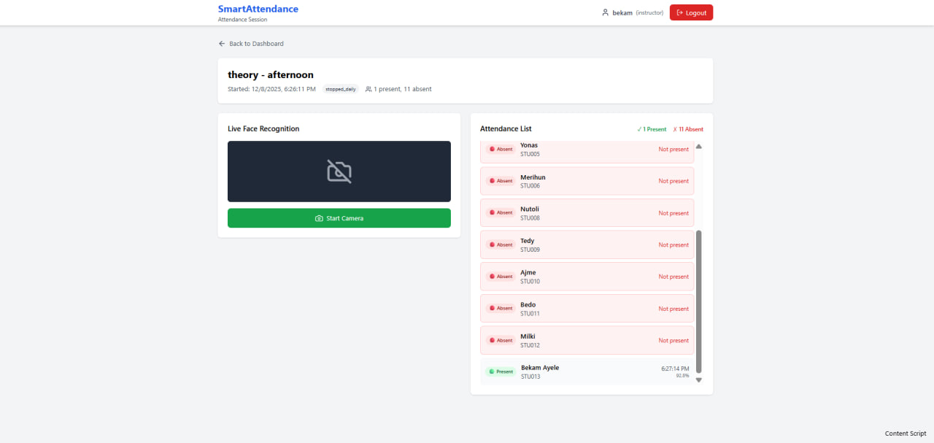
Figure 6.4: Attendance Session Page

6.2.5 Instructor Reports Page
Instructors can generate attendance reports by selecting date, course, or section. Reports can be downloaded in CSV or Excel formats.
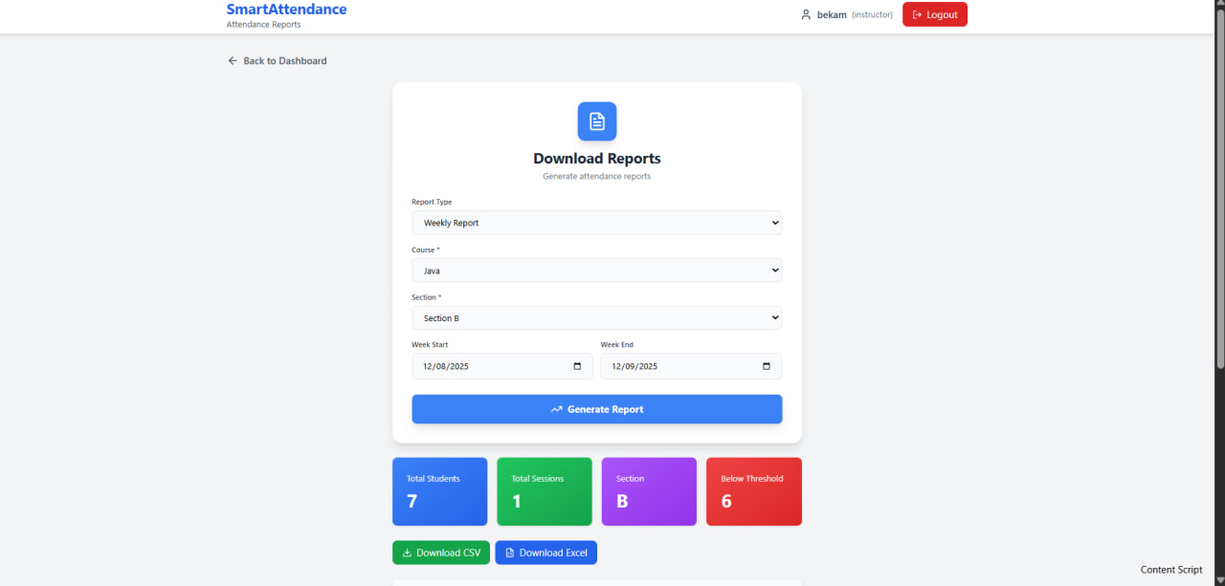
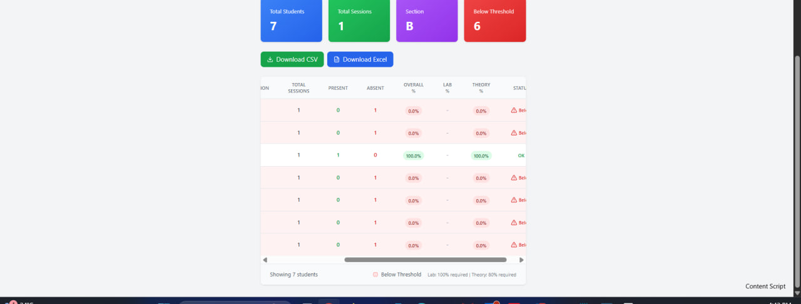
Figure 6.5: Instructor Reports Page

6.2.6 Student Dashboard
Students can check their attendance history, filter data, and view attendance summaries. The interface is responsive and easy to use.
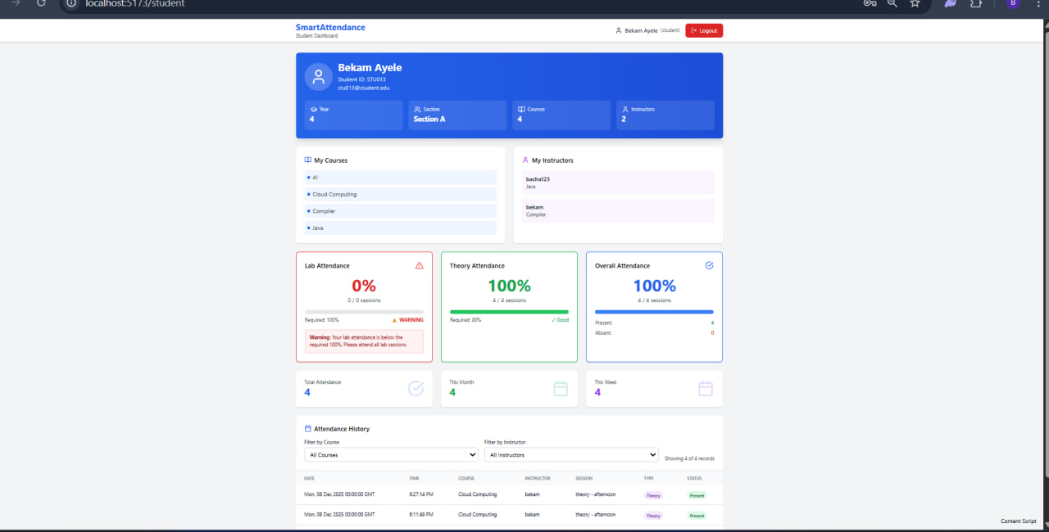
Figure 6.6: Student Dashboard

6.2.7 Password Reset Pages
The system provides a secure password reset process. Users can request a reset link via email and set a new password using the reset page, which includes a password strength indicator and validation messages.
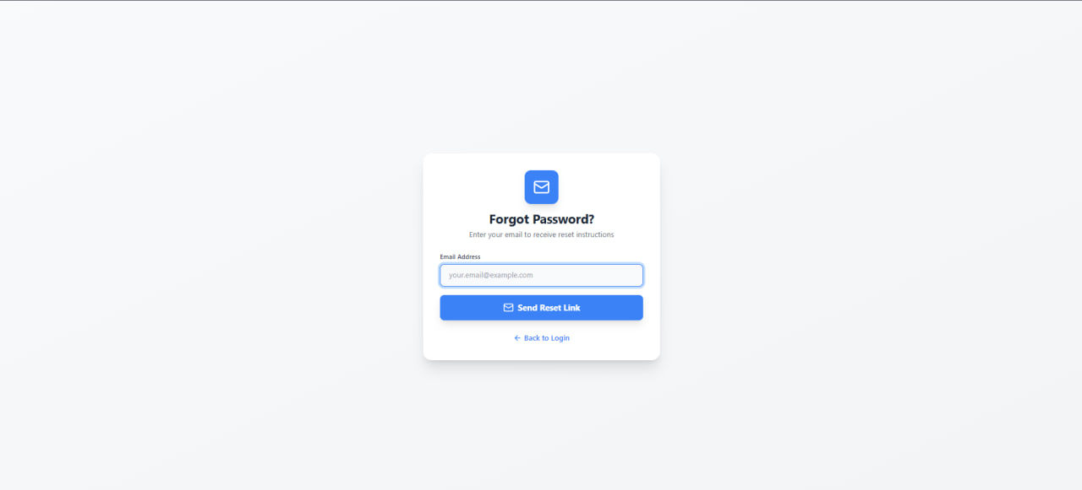
Figure 6.6: Password Reset Page

6.3 Testing
Testing ensured the system met all functional and performance requirements. Both individual components and full workflows were tested.

6.3.1 Unit Testing
Unit tests checked authentication, face detection, recognition accuracy, session handling, and attendance logging. All units performed as expected, validating core logic.

6.3.2 System Testing
System testing validated end-to-end functionality. Complete workflows such as starting a session, recording attendance, stopping the camera, reopening sessions, generating reports, and exporting data were tested successfully. Concurrent access by multiple instructors worked without conflicts, and data integrity was maintained throughout the process.

6.3.3 Acceptance Testing
Acceptance testing ensures that the Smart Attendance System fulfills the expected user requirements and is ready for real-world deployment. The system underwent User Acceptance Testing (UAT) where instructors, students, and administrators interacted with the system in realistic scenarios to validate its usability and accuracy. Instructors tested the daily attendance workflow, confirming that student recognition using the camera is fast, accurate, and significantly more convenient than traditional manual methods. They also tested the attendance correction mechanism using the 12-hour session reopening feature, which they found particularly useful for managing late arrivals. Additionally, instructors evaluated the report-generation module and expressed satisfaction with how intuitive it is to generate monthly summaries and export them for analysis.
Students participated by accessing their dashboards, reviewing attendance history, applying filters, and confirming the accuracy of their records. They also tested the password reset flow and reported that the email recovery process works efficiently and is easy to follow. Administrators evaluated user management tasks such as adding instructors, assigning courses, monitoring sessions, and exporting system-wide attendance data. Their feedback confirmed that the admin dashboard provides full visibility and is simple to navigate. Overall, all user groups accepted the system and provided positive feedback regarding its speed, ease of use, and clarity.

6.3.4 Performance Testing
Performance testing was conducted to evaluate how efficiently the system operates under different loads, ensuring that the face recognition process, database interactions, and overall responsiveness meet acceptable performance standards. The system demonstrated strong results, with face recognition averaging between 1.5 to 2.5 seconds, matching the target range. Database queries consistently responded within acceptable limits, and pages loaded quickly across all tested devices. Multiple sessions were run concurrently to simulate real classroom environments, and the system maintained stability without slowdown or conflict.
Load testing confirmed that the system could handle large datasets of more than a thousand attendance records while still producing reports in just a few seconds. This demonstrates solid scalability. The primary performance-intensive component was face recognition, which is expected due to its computational nature. Several optimizations were applied, including improved database indexing, efficient connection handling, and image compression, all of which contributed to smoother performance. The final results show that the system meets or exceeds performance expectations across all major metrics.

6.4 Features to be tested and not to be tested

6.4.1 Features to be Tested
The system includes several core features that must be tested thoroughly to ensure operational accuracy and reliability. These include authentication and authorization mechanisms, where user login, session handling, and role-based access control are verified. Face recognition components must be tested for detection accuracy, confidence threshold validation, and correct identification of students. Attendance recording processes are also critical, including handling duplicate attempts, validating student sections, and ensuring that absent students are correctly marked. Session management requires validation of session creation, status transitions, and the 12-hour reopening feature. Data management must verify correctness of CRUD operations, constraint handling, and protection against SQL injection. Reporting features are tested to ensure accurate calculations and proper export functionality. Finally, all user interface components undergo usability testing to confirm smooth navigation, responsive layouts, and compatibility across different browsers.

6.4.2 Features Not to be Tested
Some components are not included in the testing scope because they rely on stable third-party systems or are outside the system's direct control. These include the internal functionality of external libraries such as React, Flask, MySQL, OpenCV, InsightFace, and bcrypt, which are already proven technologies. Browser-level features such as webcam access and rendering engines are also not tested, as they are controlled by the browser itself. Network-related dependencies such as internet speed, hardware performance, and operating system behavior lie outside the application’s responsibility. Email delivery, which depends on external mail servers and routing systems, is also excluded. Future planned features that have not been implemented, such as a dedicated mobile app, real-time notifications, cloud automation, and multilingual support, are naturally not subject to current testing.

6.4.3 Pass/Fail Criteria
A feature passes if it works according to requirements, handles invalid input, maintains correct data, meets performance targets, and follows security rules. Failures are categorized as critical, major, or minor. The system passed most tests, with only small UI issues identified and fixed.

6.5 System Manual (Documentation)

6.5.1 User Manuals
The user manuals provide clear instructions for administrators, instructors, and students to operate the system effectively. Administrators learn how to manage users, configure courses, monitor sessions, and export complete datasets. Instructors are guided through logging in, creating sessions, recording attendance using face recognition, reopening sessions, generating reports, and managing their profiles. Students are shown how to navigate their dashboards, check attendance history, apply filters, and manage their passwords. These manuals ensure that users of all roles can confidently use the system without requiring extensive training.

6.5.2 Technical Documentation
Technical documentation explains the system architecture, backend logic, authentication flow, database schema, security practices, deployment steps, and backup instructions. It ensures long-term maintenance and easier developer onboarding.

6.5.3 Code Documentation
Code documentation describes frontend components, backend modules, API endpoints, database operations, and error-handling approaches. This supports future development and debugging.

6.6 Support and Service

6.6.1 Technical Support
The system includes a multi-level support structure to address user and technical issues efficiently. General users receive support for common problems such as login difficulties, password resets, and navigation questions. More advanced technical issues like face recognition troubleshooting, database errors, or system performance concerns are handled by a higher support tier. Development-level support is responsible for bug resolutions, feature enhancements, and security updates, ensuring the system remains stable and reliable.

6.6.2 Maintenance Services
Maintenance procedures are essential to keep the system functioning smoothly. Regular maintenance includes data backups, server health monitoring, log reviews, and applying performance optimizations. Preventive maintenance ensures long-term stability by retraining face recognition models when new data accumulates and optimizing database structures. Corrective maintenance addresses bugs, fixes data issues, and restores system functionality when unexpected failures occur.

6.6.4 Training and Onboarding
Training programs help users become familiar with the system. New users receive introductory sessions that cover essential features, while administrators receive additional training on system maintenance, monitoring, and troubleshooting. Continuous education keeps users informed about new features, best practices, and security guidelines. This ensures smooth onboarding and consistent user confidence.

CHAPTER SEVEN

CONCLUSION AND RECOMMENDATION

7.1 Conclusion
The Smart Attendance System successfully replaces the traditional manual attendance method with an automated, fast, and accurate face-recognition approach. Using React on the frontend, Flask on the backend, MySQL as the database, and InsightFace/OpenCV for recognition, the system provides reliable real-time performance. Recognition time averages between 1–3 seconds, and the minimum confidence threshold ensures that only valid matches are recorded.
The role-based access flow allows administrators, instructors, and students to work within their assigned permissions. Instructors can create sessions, reuse the 12-hour reopening feature, mark attendance automatically, and download reports. Students can view their personal attendance history, while administrators can manage users and system-wide data. Features like automatic absent marking and exportable reports support academic operations effectively.
Testing outcomes confirmed that the system works reliably with correct face detection, session management, authentication, and database interactions. Performance tests also showed stable operation under concurrent sessions and large attendance datasets. Security measures such as bcrypt hashing, JWT authentication, and controlled access to sensitive functions help ensure safe and authorized system usage.
Although the system works well, it still depends on image quality, lighting, and the variety of training data. Despite these limitations, the project demonstrates that a facial-recognition-based attendance system can be deployed ethically and effectively in classrooms. Its modular structure and full documentation also make the system ready for future improvement and expansion.

7.2 Recommendation

System Improvements
To further enhance the system, the training dataset can be expanded to include more face samples under different lighting and poses. Periodic model retraining is recommended to maintain accuracy. A controlled manual override could be added for instructors when recognition fails due to technical issues. Mobile applications would make access easier for students and instructors, and adding real-time alerts would improve communication. Advanced analytics could help institutions identify patterns such as low attendance trends or at risk students.

Technical Enhancements
Future technical improvements could include migrating the system to cloud platforms such as AWS, Azure, or Google Cloud to increase scalability, reliability, and ease of deployment across multiple campuses. Additional performance improvements could be achieved by introducing caching, refining database indexing, and adopting asynchronous processing for compute-heavy tasks. Enhancing biometric security with encrypted embeddings would strengthen privacy compliance. Integrating the system with learning management systems such as Moodle, Canvas, or Blackboard would streamline course synchronization and provide unified academic insights.

Operational Recommendations
To ensure smooth adoption, ongoing user training is essential for instructors, students, and administrators. Orientation sessions and well-prepared videos or manuals would help users understand system features more effectively. A phased deployment approach, starting with pilot departments, would allow institutions to refine the system before large-scale rollout. Regular retraining of recognition models and continuous dataset updates should be implemented to sustain accuracy over time. Clear privacy policies must be established to address consent, retention, and deletion of biometric data, ensuring responsible and ethical system operation. Reliable backup procedures must also be maintained, including automated daily backups, tested restoration processes, and secure storage practices.

Future Research
Promising areas for future research include the integration of multi-modal biometrics that combine facial recognition with additional features such as voice or gait patterns to improve reliability. Exploring edge computing could reduce data transmission needs and enhance privacy by processing recognition locally on devices. Explainable AI techniques could provide transparency by showing which features influence recognition decisions. Additionally, implementing adaptive learning mechanisms could automatically update facial models as student appearances evolve over time, ensuring long-term accuracy and system resilience.
Expansion Beyond Educational Use
Beyond classroom attendance, the system can be expanded into a complete Employee Management System. By extending the facial recognition engine to support workplace check-in/out, working-hour tracking, shift monitoring, and automated productivity reports, the system can be used in organizations with large numbers of employees. This makes the project scalable beyond schools and suitable for offices, industries, and public institutions that require secure and automated workforce management.

REFERENCES
- Books & Research
Bradski, G., & Kaehler, A. (2008). Learning OpenCV: Computer Vision with the OpenCV Library. O’Reilly Media.
Grinberg, M. (2018). Flask Web Development (2nd ed.). O’Reilly Media.
Banks, A., & Porcello, E. (2020). Learning React (2nd ed.). O’Reilly Media.
Schroff, F., Kalenichenko, D., & Philbin, J. (2015). FaceNet: A Unified Embedding for Face Recognition. Proceedings of IEEE CVPR.
Deng, J., Guo, J., Xue, N., & Zafeiriou, S. (2019). ArcFace: Additive Angular Margin Loss for Deep Face Recognition. IEEE CVPR.
Wang, M., & Deng, W. (2021). Deep Face Recognition: A Survey. Neurocomputing, 429, 215–244.
- Official Documentation
OpenCV Documentation. (2024). https://docs.opencv.org
InsightFace Documentation. (2024). https://insightface.ai
React Documentation. (2024). https://react.dev
Flask Documentation. (2024). https://flask.palletsprojects.com
MySQL Reference Manual. (2024). https://dev.mysql.com/doc
TensorFlow Tutorials. (2024). https://www.tensorflow.org/tutorials
- Standards & Guidelines
ISO/IEC 19794-5:2011. Biometric Data Interchange Formats Face Image Data.
General Data Protection Regulation (GDPR). (2018). EU Regulation 2016/679.
Ethiopian Ministry of Education. (2021). Guidelines for Data Privacy in Educational Technologies.
APPENDIX
Appendix A: Database Schema Summary
- Users — user_id, username, password_hash, role, email, created_at
- Students — student_id (FK), name, email, section, year, face_encoding
- Instructors — instructor_id (FK), name, email, department, courses (JSON)
- Sessions — session_id, course_id, instructor_id, section, year, session_type, time_block, start_time, end_time, status
- Attendance — attendance_id, session_id (FK), student_id (FK), status, confidence, timestamp, date
B. API Endpoints
Authentication
- POST /api/auth/login
- POST /api/auth/reset-password
Sessions
- POST /api/sessions/create
- PUT /api/sessions/:id/end
- PUT /api/sessions/:id/reopen
Attendance
- POST /api/attendance/detect-face
- GET /api/attendance/session/:id
Reports
- GET /api/reports/generate
- GET /api/reports/export
Admin
- GET /api/users
- POST /api/users/create
- PUT /api/users/:id
C. Configuration Parameters
Face Recognition
- Confidence threshold: 60%
- Model: retinaface_r50_v1
- Image size: 112×112
Session Management
- Reopen window: 12 hours
- Auto-end: Enabled
Security
- JWT expiry: 24 hours
- Minimum password length: 8
- Bcrypt rounds: 12
Performance
- DB pool size: 10
- Max active sessions: 50
D. User Permissions Matrix

|Feature | Admin | Instructor | Student
Create Sessions | ✗ | ✓ | ✗
Mark Attendance | ✗ | ✓ | ✗
View Attendance | ✓ | ✓(own) | ✓(own)
Generate Reports | ✗ | ✓(own) | ✓(own)
Export Data | ✓ | ✓(own) | ✗
Manage Users | ✓ | x | x
Reopen Sessions | ✓ | ✓(own) | x

Table 7.1 User Permissions Matrix
SAMPLE CODE
Sample 1: Face Recognition Core (Python)
import cv2
import numpy as np
from insightface.app import FaceAnalysis
class FaceRecognitionSystem:
def __init__(self):
self.app = FaceAnalysis(name='buffalo_l')
self.app.prepare(ctx_id=0, det_size=(640, 640))
self.known_faces = {}
self.threshold = 0.60
def detect_and_recognize(self, frame):
results = []
faces = self.app.get(frame)
for face in faces:
embedding = face.embedding
best_match, best_distance = None, float('inf')
for student_id, known_emb in self.known_faces.items():
distance = np.linalg.norm(embedding - known_emb)
if distance < best_distance:
best_distance = distance
best_match = student_id
confidence = 1 - (best_distance / 2)
if confidence >= self.threshold:
results.append({
'student_id': best_match,
'confidence': float(confidence),
'bbox': face.bbox.astype(int).tolist()
})
return results

Sample 2: Authentication API (Python)
from flask import Blueprint, request, jsonify
from werkzeug.security import check_password_hash
import jwt, datetime
auth_bp = Blueprint('auth', __name__)
SECRET_KEY = 'your-secret-key'
@auth_bp.route('/login', methods=['POST'])
def login():
data = request.get_json()
username = data.get('username')
password = data.get('password')
cursor.execute(
"SELECT user_id, password_hash, role FROM users WHERE username = %s",
(username,)
)
user = cursor.fetchone()

if not user or not check_password_hash(user['password_hash'], password):
return jsonify({'error': 'Invalid credentials'}), 401
token = jwt.encode({
'user_id': user['user_id'],
'role': user['role'],
'exp': datetime.datetime.utcnow() + datetime.timedelta(hours=24)
}, SECRET_KEY, algorithm='HS256')
return jsonify({'token': token, 'role': user['role']}), 200
Sample 3: Session Management API (Python)
@sessions_bp.route('/create', methods=['POST'])
@token_required
def create_session(current_user, current_role):
data = request.get_json()
cursor.execute(
"""INSERT INTO sessions
(instructor_id, course_name, section, year, session_type,
time_block, start_time, status)
VALUES (%s, %s, %s, %s, %s, %s, %s, 'active')""",
(current_user, data['course'], data['section'], data['year'],
data['session_type'], data['time_block'], datetime.now())
)
conn.commit()
return jsonify({'session_id': cursor.lastrowid}), 201
Sample 4: React Attendance Component (TypeScript)
import React, { useState, useEffect, useRef } from 'react';
import { detectFace } from '../lib/api';
export const AttendanceSession: React.FC = () => {
const videoRef = useRef<HTMLVideoElement>(null);
const [attendanceList, setAttendanceList] = useState([]);
const [isCapturing, setIsCapturing] = useState(false);
useEffect(() => {
startCamera();
const interval = setInterval(captureAndRecognize, 2000);
return () => clearInterval(interval);
}, []);
const startCamera = async () => {
const stream = await navigator.mediaDevices.getUserMedia({ video: true });
if (videoRef.current) videoRef.current.srcObject = stream;
};
const captureAndRecognize = async () => {
if (!isCapturing) return;
const canvas = document.createElement('canvas');
canvas.width = videoRef.current.videoWidth;
canvas.height = videoRef.current.videoHeight;
canvas.getContext('2d')?.drawImage(videoRef.current, 0, 0);

const imageData = canvas.toDataURL('image/jpeg');
try {
const result = await detectFace(sessionId, imageData);
if (result.recognized) {
setAttendanceList(prev => [...prev, result.student]);
}
} catch (err) {
console.error('Recognition failed:', err);
}
};
return (
<div className="attendance-session">
<video ref={videoRef} autoPlay />
<button onClick={() => setIsCapturing(!isCapturing)}>
{isCapturing ? 'Stop Camera' : 'Start Camera'}
</button>
<div className="attendance-list">
{attendanceList.map(student => (
<div key={student.id}>
{student.name} - {student.confidence}%
</div>
))}
</div>
</div>
);
};

